Supplementary material to

Flexible solution concepts for sustainable drinking water production in the Netherlands

Nogueira, G.E.H.^{1,*}, Meeusen, R.¹; Terwisscha van Scheltinga, R.C.²; Hoogland, T.²; Jansen, S.¹; Nijsten, G.J.¹; Pouwels, J.¹; de Louw, P.G.B.^{1,3}; Kuin P.⁴; Peters J.H.⁴; Passier H.F.¹

¹: Deltares, Utrecht, The Netherlands.
²: Vitens NV, Zwolle, The Netherlands.
³: Soil Geography and Landscape , Wageningen University & Research, Wageningen, The Netherlands.
⁴: Royal HaskoningDHV, The Netherlands.
* corresponding author: guilherme.nogueira@deltares.nl

In this document, we provide the sources and methods used to produce the suitability maps from each solution concept. Table S1 shows a compilation of information types, sources, and how this was used on the calculations. Additional explanation to the decision and selection of areas, as well as examples of locations are also presented in the text below.

Table S1: Information and sources used for delineating suitability maps for the different solution concepts. Detailed information on how the different datasets were combined and used to produce the suitability maps for each concept can be found below.
Type of information | Source | Example of how the data was used for concept's suitability map
Soil types | https://www.wur.nl/nl/show/bodemkaart-van-nederland.htmhttps://www.wur.nl/nl/show/bodemkaart-van-nederland.htm | Presence of clay and/or loam in the subsoil.  For example, locations with these units in the first 1.20 m were assigned as unsuitable (low infiltration capacity) for the Water Battery
Vertical extensions of sedimentary units (presence of clayey units with depth) | REGIS II, Hydrological Model (https://basisregistratieondergrond.nl/inhoud-bro/registratieobjecten/modellen/regis-ii-hydrogeologisch-model-hgm/) | Presence of clayey horizons between aquifers.  For example, for the Switching between Extraction (vertically) a semi-confining layer between shallow and deeper aquifers is imperative
Drought-impacted areas and calculations for the Netherlands | https://droogteportaal.nl/rapporten/Droogte_zandgronden_fase_3.pdf  and  https://droogteportaal.nl | Presence of sandy aquifers with groundwater storage potential of > 5 cm by underground infiltration, and a contiguous area of >100 ha with underground storage capacity of > 2,5 m (see groundwater levels). For example, for the Switching between Extraction (horizontally) a proximity of 5km to such an area is considered optimal
Aquifer units and groundwater quality (permeabilities, fresh-salt interface depths, Chloride concentrations) | National Hydrological Model (https://nhi.nu/modellen/lhm/, results available at: https://www.klimaateffectatlas.nl/nl/) | Depth of fresh-salt interface and permeability of geological units.  For example, locations with hydrogeological units presenting high permeabilities (100 m2/d) and freshwater at>50m and top of brackish water at <-150m below NAP received high scores for the Fresh/Salt
Groundwater levels | National Hydrological Model (https://nhi.nu/modellen/lhm/, results available at: https://www.klimaateffectatlas.nl/nl/)) | Difference between mean highest groundwater level (GHG) and the mean lowest groundwater level (GLG).  Areas showing >5m difference between GHG and GLG were considered optimal for Water Battery
Existing built-up area and populations | Climate Impact Atlas (https://www.klimaateffectatlas.nl/en/)  and  Centraal Bureau voor de Statistiek (https://www.cbs.nl/nl-nl) | Urban extensions and populations.  Cities were classified according to their population for the Resource City

The collected data and information were grouped in a Geographic Information System, and the suitability maps were produced using a simple GIS Multi Criteria Decision Analysis (GIS-MCDA) (Malczewski 1999; 2015). Potential areas for each concept were defined as promising if criteria and requirements related to each of them were fulfilled. Additional explanation to the criteria and selection of areas, as well as examples of locations are also presented in the text below.

Water battery
This map used the differences between the Mean Highest Groundwater Level (GHG) and the Mean Lowest Groundwater Level (GLG), as calculated with LHM and made available from https://www.klimaateffectatlas.nl/nl/ (status 2022). Areas identified as potentially promising are those where the difference between the GHG and GLG is 5 m or more. The areas where the soil map of the Netherlands (https://www.wur.nl/nl/show/bodemkaart-van-nederland.htm) shows clay loam in the subsoil in the first 1.20 m have been removed due to limited or very low infiltration capacities.

Fresh/Salt

Possible opportunity for fresh and salt
This was created by using a map showing the depth of the boundary between fresh and salt water in the Netherlands. For example, local geophysical data can be used to better define this interface. The map shows the areas where this interface is between 50 and 150 m below NAP.
A improved method for making such type of map has been described within the COASTAR project. The method for this is described in https://www.coastar.nl/wp-content/uploads/COASTAR-Kansrijkheidskaart-Nederland-Ondergrondse-waterberging.pdf and https://www.coastar.nl/wp-content/uploads/11204487-001-BGS-0005_v0.2-Regionale-en-nationale-opschaling-COASTAR-toepassingen.pdf. Then, to create the map, the following properties of the 8 distinct layers from the National Hydrological Model (LHM) in the subsurface were analyzed:
- Background flow
- Drive Up
- Burst index
- Passing power

Potentially promising areas for extraction of brackish water
The suitability of the layers is based on the eight aquifers in the LHM model. This applies to the west/low Netherlands. It has not (yet) been examined for the high/eastern Netherlands. Once more, the method was based on the one from COASTAR, which looked at the following properties for the layers:
- Average chloride concentration in the brackish water package.
- Thickness brackish water package
- Permeability
- Maximum depth brackish water package
A description of the method can be found in https://www.coastar.nl/wp-content/uploads/COASTAR-Kansrijkheidskaart-Nederland-Brakwaterwinning.pdf and https://www.coastar.nl/wp-content/uploads/11204487-001-BGS-0005_v0.2-Regionale-en-nationale-opschaling-COASTAR-toepassingen.pdf

Risk zone of increase lateral salinization
This layer is based on a sketch by Vitens NV (see figure below), which roughly delineates areas where salinization will continue to increase in the future in the Netherlands. This was done based on local knowledge and internal discussions with experts based on local data and analyses available to Vitens. More accurate and refined delineation can be complemented with, for example, other LHM and modelling results.

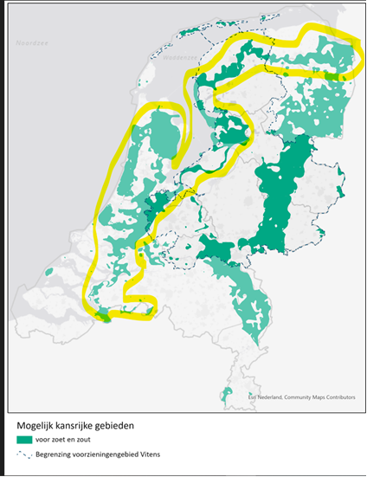
Figure S1: Sketch done by Vitens experts on the increasing lateral salinization risk in the Netherlands (yellow areas).

Switching between extractions

Horizontal switching

A number of sources were used to create this map. First, calculations of the effects of the underground infiltration from the study of drought on sandy soils (https://droogteportaal.nl/rapporten/Droogte_zandgronden_fase_3.pdf and www.droogteportaal.nl) were used. Where these values had an effect of more than 5 cm (i.e., presence of sandy aquifers with groundwater storage potential of > 5 cm by underground infiltration), the areas have been designated as higher grounds and surroundings. Because this only covers the areas in the eastern Netherlands with the exception of southern Limburg, this was supplemented by looking at the areas in the Netherlands where the difference between the GHG and GLG is greater than 2.5 m, and which have an area of more than 100 ha. These areas are also designated as high ground and surroundings. Then, all areas within 5 km from the boundary of the high ground and surrounding areas were designated as promising areas around the high ground.

Vertical switching
The Hydrological model REGIS II was used to create this map. Areas where at least one of the following layers was present in the subsurface were designated as promising:
- 1st clay layer of the formation of Eem
- 1st clay layer of the formation of Kreftenheye, Layer Package of Twello present
- 3rd clay layer of the Waalre formation
- 1st clay layer of the formation of Waalre
- 1st clay layer of the Formation of Drente, Uitdam Clay Package

Resource City
To create this map, two different data sources were used. First, the existing built-up areas were taken from the Climate Impact Atlas. Then, to link the population numbers to the built-up areas, a CBS file (2020 version) was used in which the population numbers are given for all municipalities. With that, cities were classified according to their population and considered as potential areas depending on their size and population.

Figure S2: snapshots of different simulation times of GW changes due to Water Battery implementation for Scenario A (only infiltration) . Blue colors indicate a rise in GW levels and red colors indicate a lowering of GW levels (which is not visible since there was no extraction in this scenario).
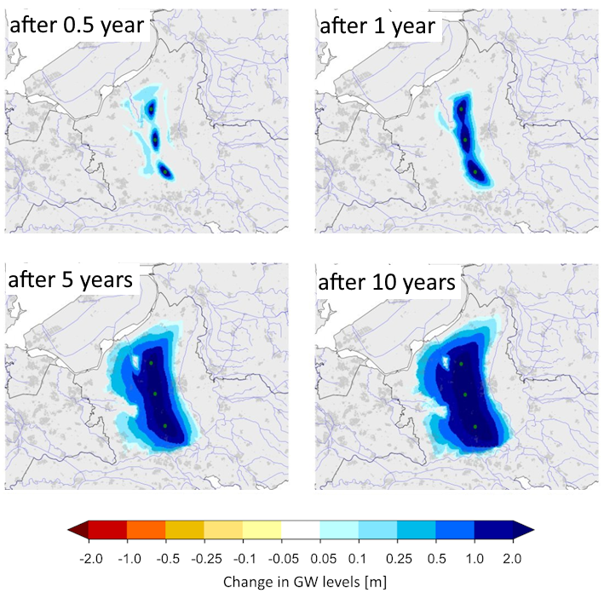

Figure S3: map showing final time step with simulated runoff for Scenario B; and simulated stream discharge for a specific stream for the scenarios A and B (without and with abstraction, respectively) (plot on the right). The figure show that even with groundwater abstraction, there is an general increase in water levels and thus stream discharge due to the implementation of Water Battery. Green and red circles on the map indicate infiltration ponds and abstraction wells, respectively. “Reference” indicates stream discharge values in a scenario without Water Battery implementation. Scenario A is showed in the plot for comparison only.
