Identifying uncertainties in geomodelling inputs: data review of Paleozoic geology in the Euregion Meuse-Rhine
Jasper Maars¹⁻², Jasper Hupkes¹, Alexander J.P. Houben², Geert-Jan Vis², Allard W. Martinius¹⁻³, Marleen de Ceukelaire⁴, Kees C. Geel⁵, Hemmo A. Abels¹

Table of contents:
- Outcrop data Table…………………………………………………………. P2
  - Bedding measurements
  - Slickensides measurements

- Borehole data…………………………………………………………………… p4
  - Cottessen (B62D1181)

  - Banholt (B62C1327)

  - Kastanjelaan-02 (KSL-02)

- Palynostratigraphy……………………………………………………… p12
  - Approach and Sampling
  - Cottessen (ETB-03)
  - Terziet-02 (ETB-02)
  - Banholt (ETB-04)
  - RWTH-01
  - Kastanjelaan-02 (KSL-02)
  - Dalhem (outcrop)

- Other data and materials…………………………………………….… p24
  - Stratigraphic mismatches in geologic map
  - Val Dieu-Dalhem road section
  - Digital elevation model
  - Geodatabase web access

- Terminology

Outcrop data

1.1 Bedding measurements
XRD | YRD | Strata | Strike (˚) | Dip (˚) | Dip direction
184125 | 301238 | Famennian | 079 | 20 | NNW
184287 | 301285 | Famennian
184213 | 300841 | Namurian
184178 | 300794 | Namurian | 040 | 45 | SE
183044 | 301670 | Namurian | 038 | 71 | SE
182987 | 301807 | Namurian | 029 | 65 | SE
182776 | 302249 | Namurian
184521 | 300889 | Namurian
184615 | 300801 | Namurian
184824 | 300820 | Namurian | 047 | 8 | S
183288 | 301743 | Namurian | 030 | 63 | SE
183175 | 300385 | Namurian
183086 | 300069 | Famennian | 057 | 20 | SE
182979 | 299806 | Namurian
185387 | 300305 | Namurian | 051 | 49 | SE
194206 | 306941 | Namurian | 046 | 18 | SSE
184133 | 301383 | Famennian | 043 | 40 | NW
180821 | 302626 | Namurian
180199 | 302874 | Westphalian | 342 | 38 | SSW
179754 | 302580 | Westphalian | 332 | 39 | SW
197647 | 302467 | Westphalian | 351 | 10 | SW
176039 | 301855 | Namurian | 080 | 90 | S
176125 | 301552 | Namurian | 046 | 18 | SSE
178805 | 302377 | Namurian | 329 | 31
177062 | 304255 | Frasnian
176342 | 302763 | Dinantian
176110 | 302320 | Dinantian | 018 | 10 | SSE
176599 | 303495 | Dinantian | 041 | 90
193353 | 308236 | Namurian | 030 | 12 | SE
193863 | 307794 | Namurian | 074 | 26 | S
195565 | 305449 | Namurian | 046 | 18 | SE
195734 | 305367 | Namurian | 007 | 28 | E
198526 | 302279 | Dinantian | 012 | 71 | W
197966 | 303476 | Famennian | 072 | 35 | S
178666 | 299639 | Westphalian
180784 | 301552 | Namurian | 047 | 28 | SE
178460 | 304311 | Frasnian
195911 | 305311 | Namurian | 053 | 19 | NW
195092 | 306072 | Namurian | 321 | 11 | NE
196927 | 303752 | Dinantian | 060 | 40 | SE
199697 | 302148 | Dinantian | 071 | 9 | SE
197165 | 303217 | Famennian | 056 | 27 | SE
200431 | 299983 | Famennian | 028 | 17 | SE
211188 | 301864 | Frasnian | 058 | 65 | SE
199386 | 299097 | Famennian | 076 | 30 | SE
198782 | 299250 | Dinantian | 038 | 40 | SE
196111 | 305659 | Namurian
205618 | 313816 | Westphalian | 059 | 58 | SSE
205633 | 314642 | Westphalian | 344 | 38 | E
206044 | 315267 | Westphalian | 080 | 90 | NNW
204388 | 318209 | Westphalian | 339 | 14 | E
204919 | 309659 | Famennian | 032 | 40 | SE
199333 | 302278 | Finantian | 035 | 40 | SE
199115 | 302432 | Dinantian | 039 | 65 | SE
183086 | 300069 | Namurian | 094 | 49 | N
Table S1.1 Bedding measurements and outcrop coordinates used to create Figure 5 in the main text. XRD and YRD correspond to the coordinate system: Amersfoort RD new. The bedding attitude in the Cottessen quarry (74, 26˚) is similar to the borehole image logs of the Cottessen borehole.

1.2 Slickensides measurements
XRD | YRD | Trend/Plunge | kinematics | bedding
193863 | 307794 | 148˚/35˚ | - | 074, 26˚ SSE
193863 | 307794 | 142˚/30˚ | - | 074, 26˚ SSE
193863 | 307794 | 155˚/45˚ | Und. SS | 074, 26˚ SSE
193863 | 307794 | 122˚/25˚ | - | 074, 26˚ SSE
194048 | 307834 | 132˚/00˚ NW | Sinistral SS | 080, 30˚ SSE
195734 | 305367 | 137˚/15˚ NW | Sinistral SS | 053, 40˚ SE
195565 | 305449 | 122˚/02˚ NW | Sinistral SS | 055, 28˚ SE
198526 | 302279 | 008˚/30˚ | - | 095, 54˚ SW
196642 | 304082 | 025˚/90˚ | ESE-WNW | 026, 90˚ ESE
183247 | 301493 | 031˚/02˚SSW | Sinistral SS | 031, 70˚ ESE
Table S1.2 Slickensides measurements. XRD and YRD correspond to the coordinate system: Amersfoort RD new.

Borehole data

2.1 Terziet-01 (ETB-01)
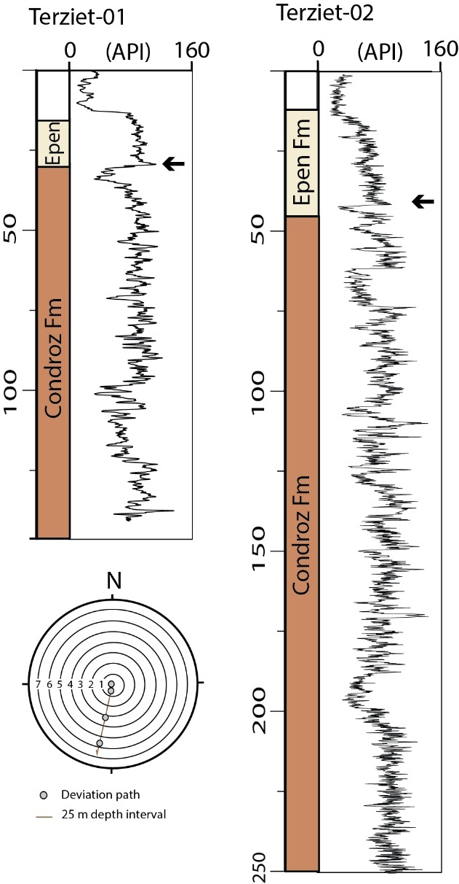
The Terziet-01 borehole was drilled at an accidental inclination towards the south (Fig. S1). The lithofacies observed in cutting samples changes from dark grey mudstone to micaceous fine sandstones at 28 m depth. The acquired gamma-ray log differs from Terziet-02 despite their nearby locations. Fault zones were not identified due to a lack of core material and borehole image logs.

Figure S2.1 Stratigraphic borehole profile of the Terziet-01 with its gamma-ray log. The arrow indicates a shift in the gamma-ray log that is also recognisable in Terziet-02. The deviation plot indicates a southward inclination of the Terziet-01 borehole.

2.2 Cottessen (ETB-03)
The Cottessen borehole encountered a 53.6 m thick succession of dark coloured shales with faint lamination and thinly alternating fine-grained sands- and mudstones (Fig. S2.2). We interpret this succession as Epen Fm. Underlying this succession are micaceous fine- to very fine grained sandstones and thinly alternating fine grained sand- and mudstones with frequent burrows. The micaceous sandstones are either massive, planar laminated, wavy laminated, or cross-laminated. Moreover, soft-sediment deformation such as slumps and loading structures, occurs. This succession from 53.6-250.1 m is interpreted as the Condroz Fm.

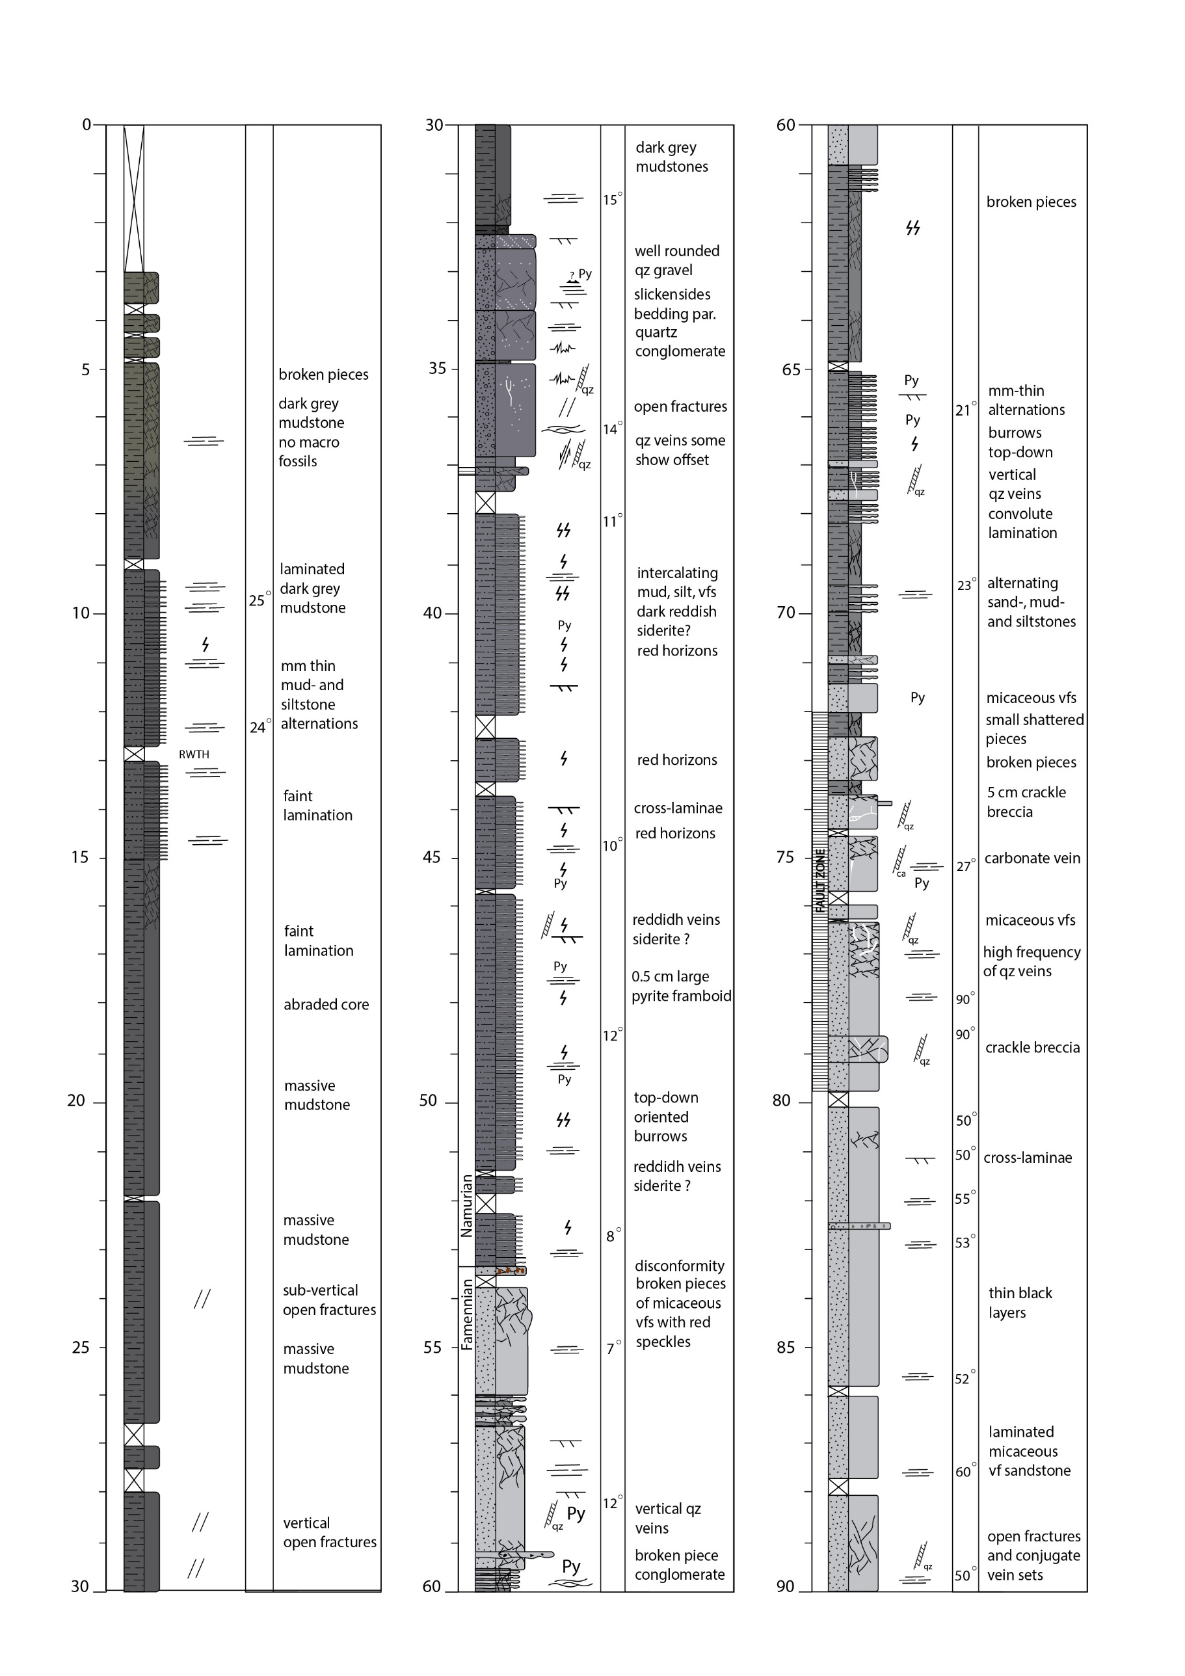

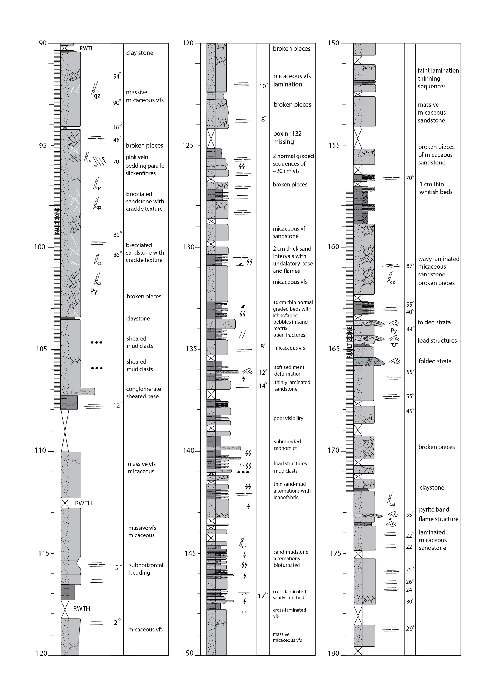

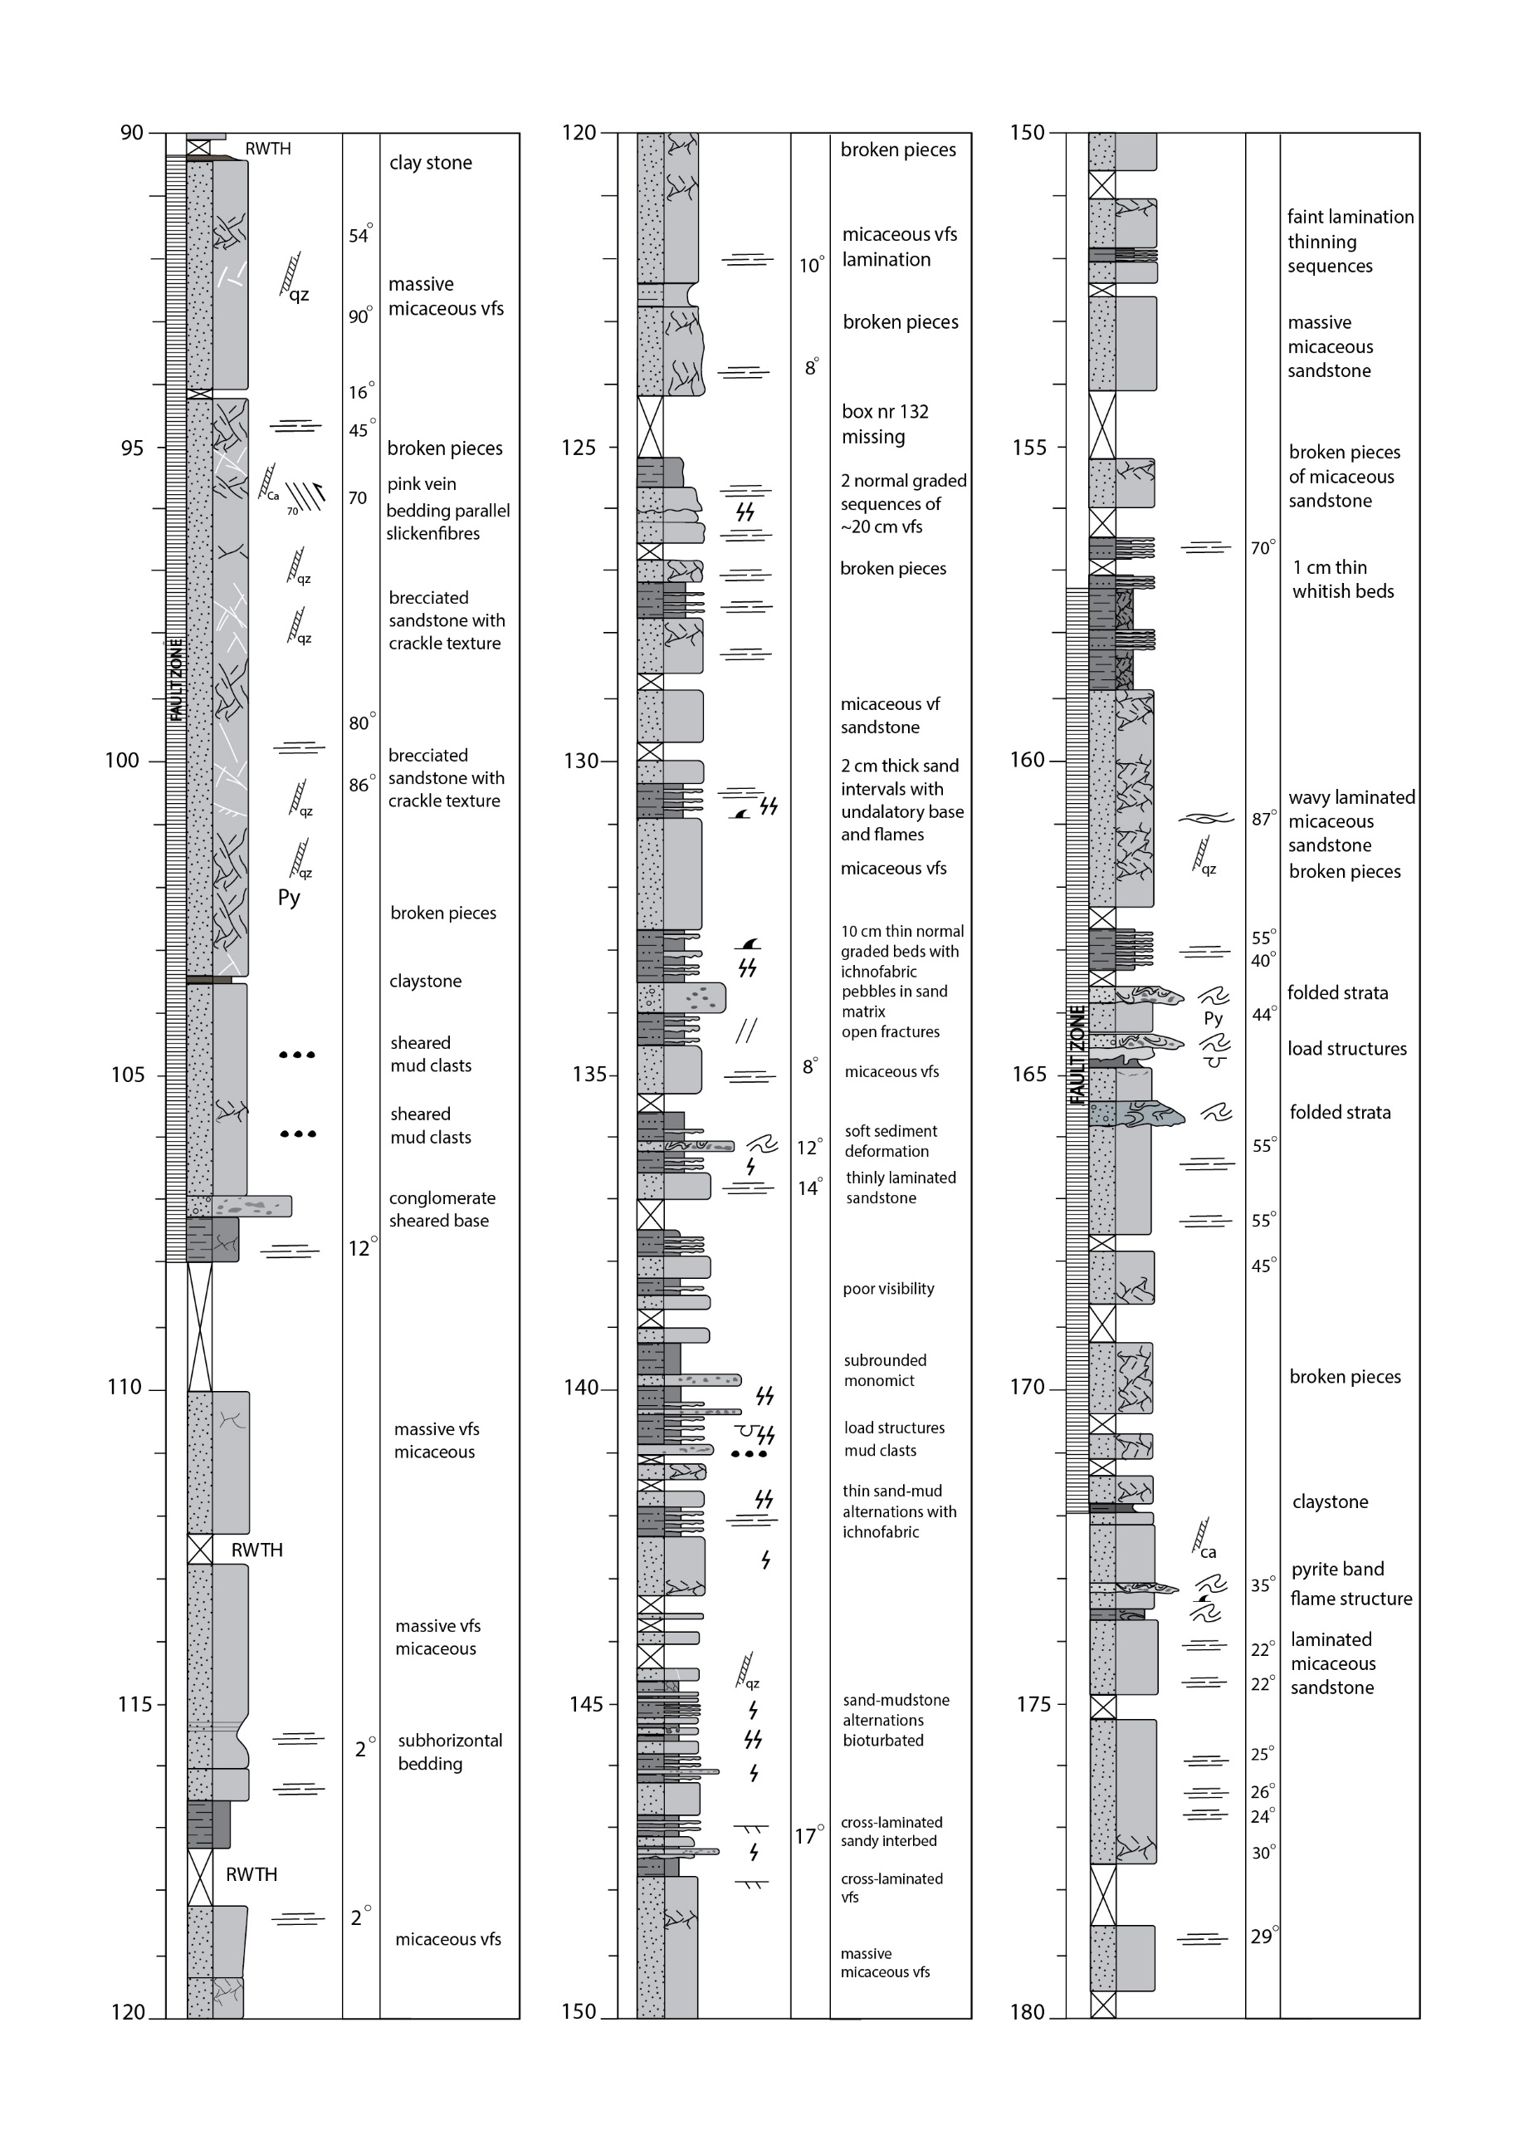

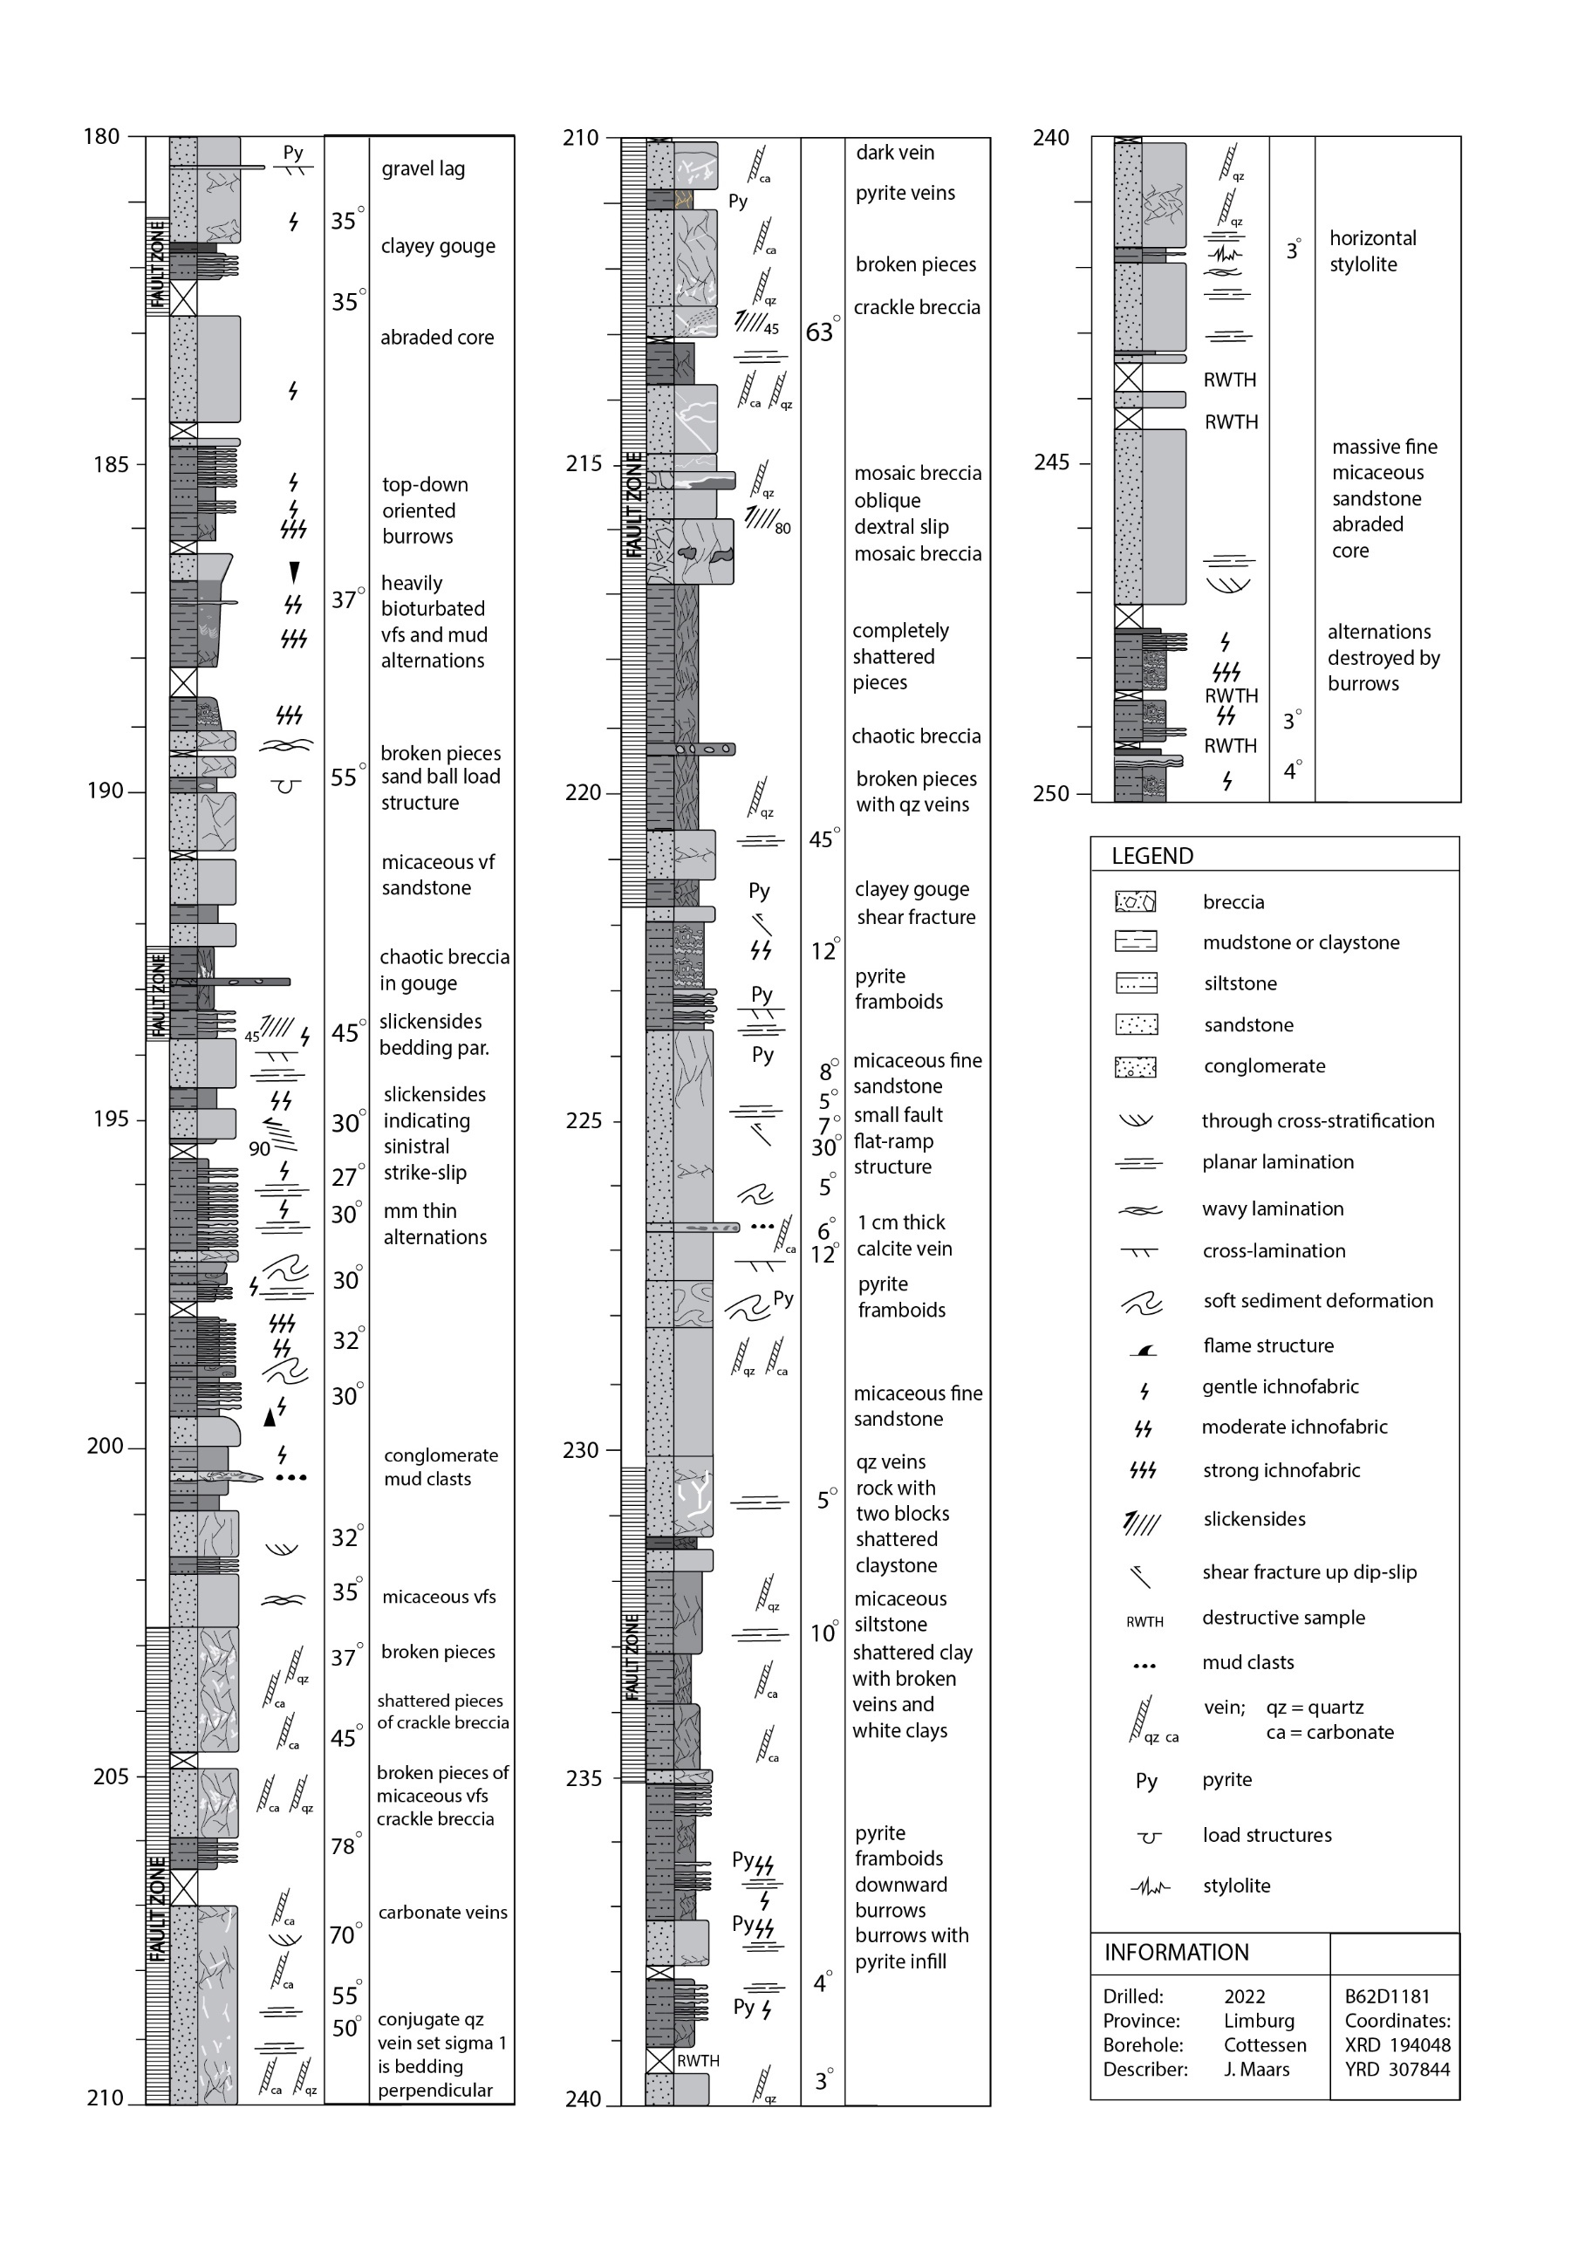

Figure S2.2. Sedimentary log of the Cottessen core (ETB-03) on previous pages.

2.2 Banholt (ETB-04)
In 2017 a 252.8 m deep borehole was drilled near Banholt (the Netherlands). The 142-230 m interval was cored and a gamma ray log and acoustic borehole images were acquired. Strata in the core consistently dip 20-45˚ with a gradual increase downcore. Strata consist of grey to dark grey mud- and siltstones and coaly intervals of up to 70 cm (Fig. S2.2). These coaly intervals are typically found in Westphalian strata but also occur in Namurian strata of the Baarlo Fm (NLOG, 2025). The borehole encounters no marine marker bed, as Maurenbecker (1945) described, limiting the lithostratigraphic interpretation. Yet, we interpreted the strata as Baarlo Fm based on what is drawn on the geologic map (RGD, 1995). However, as palynomorphs were all indiscernible the stratigraphic interpretation is inconclusive and comes with uncertainty.

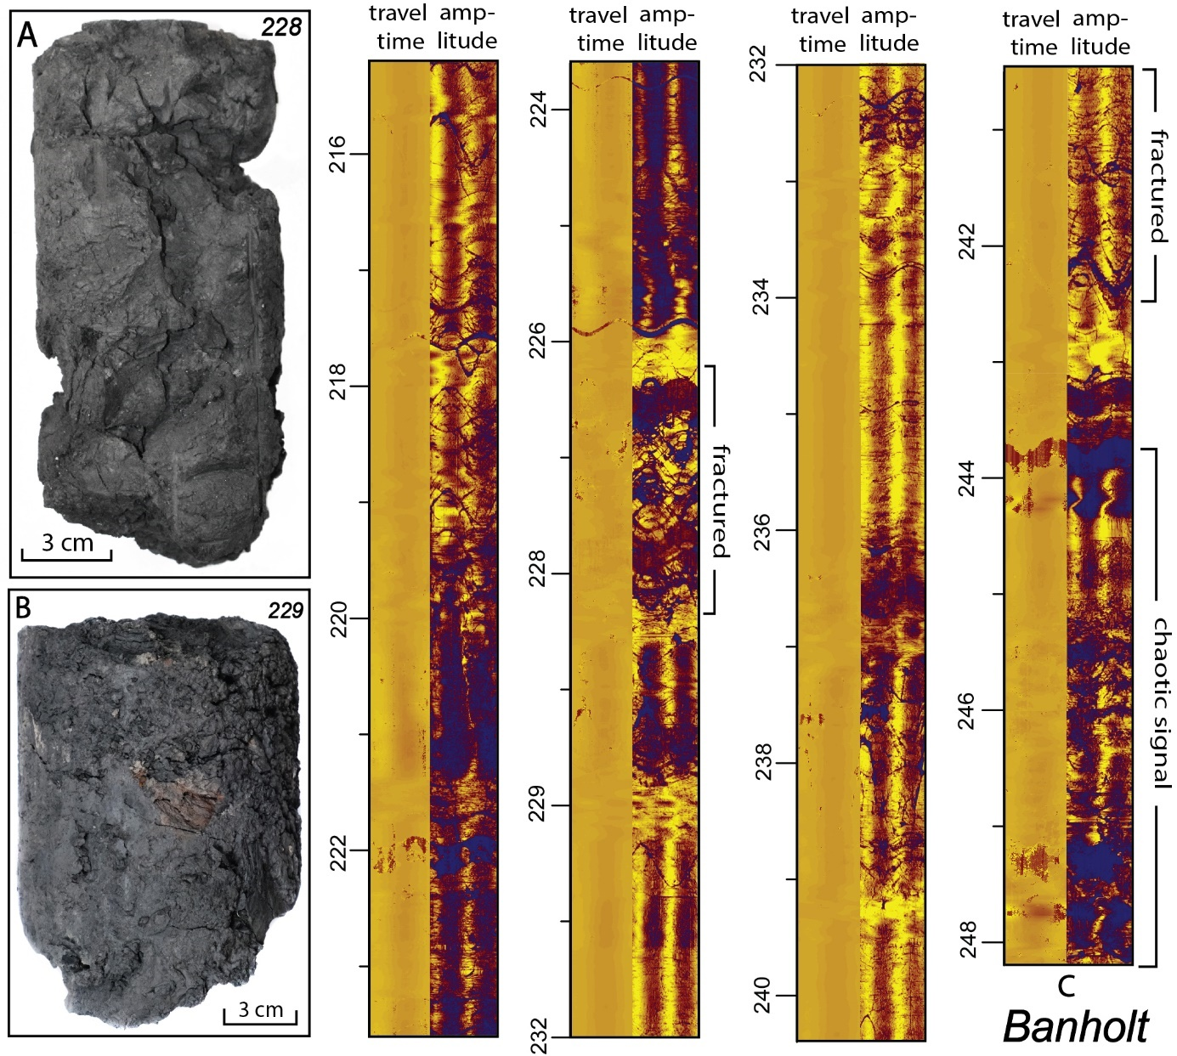
Figure S2.3 A) clayey gouge at 228 m in Banholt core. B) Fine-grained chaotic breccia at 229 m. C) Acoustic borehole images showing heavily fractured intervals and a chaotic signal at the base. The basal 25 m of the Banholt borehole is interpreted as a fault zone.

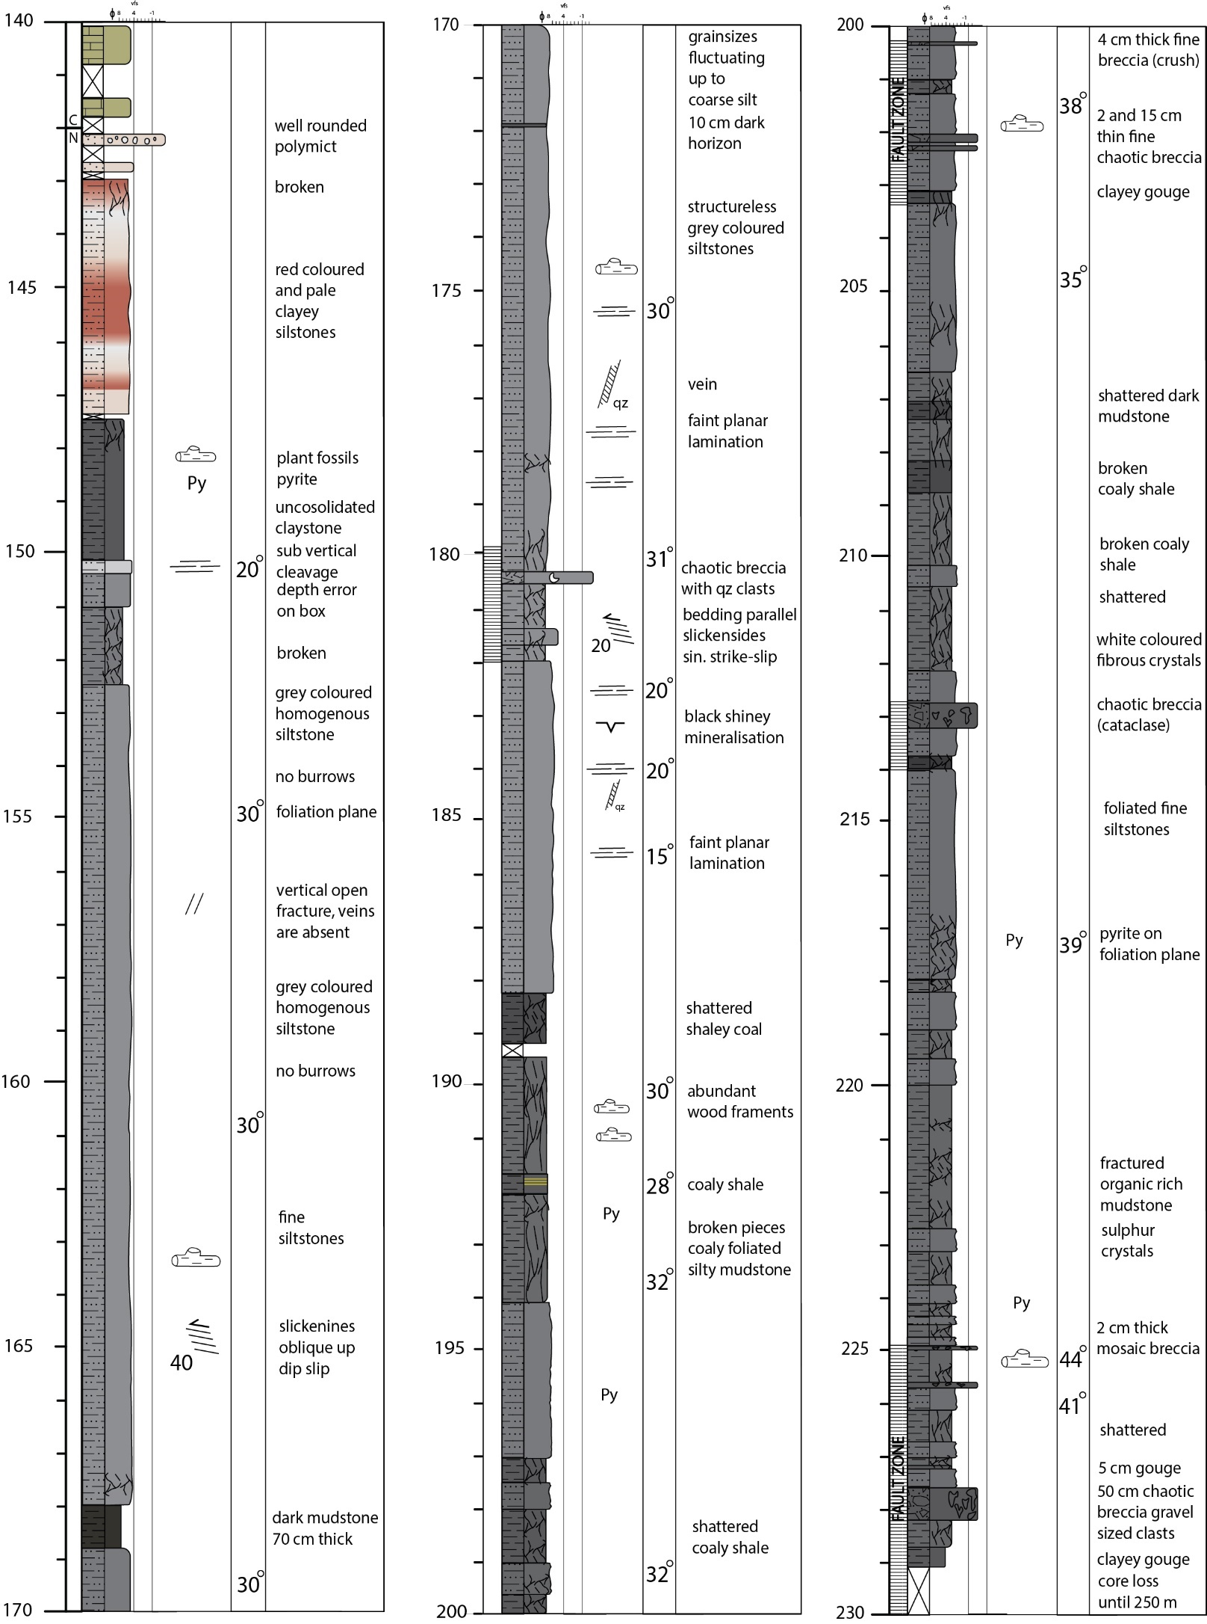

Figure S2.4 Sedimentary log of the Banholt core (ETB-04).

2.3 Kastanjelaan-02 (KSL-02)
Famennian strata in the KLS-02 core are characterised by micaceous siliciclastics with various sedimentary structures (Bless et al., 1981a). Additionally, burrowed horizons and conglomerate intercalations are present (Fig. S2.5). The Famennian lithofacies change near a paleokarst horizon at 465.4 m from dominantly micaceous sandstones to burrowed carbonate-mudstone alternations. The top of this burrowed interval is cut by an interpreted normal fault (459.3-452.3 m) containing chaotic breccias and shear fractures. The strata above this fault comprise crinoidal-rich carbonates (Fig. S2.5) and a ~2 m thick interval of dark-coloured carbonate mudstones at 446.30-444 m. Based on the sharp contrast in lithofacies above and below the fault zone (459.3-452.3 m), we interpret the centre of the fault as the lithostratigraphic contact between Condroz Fmand Hastière Fm.

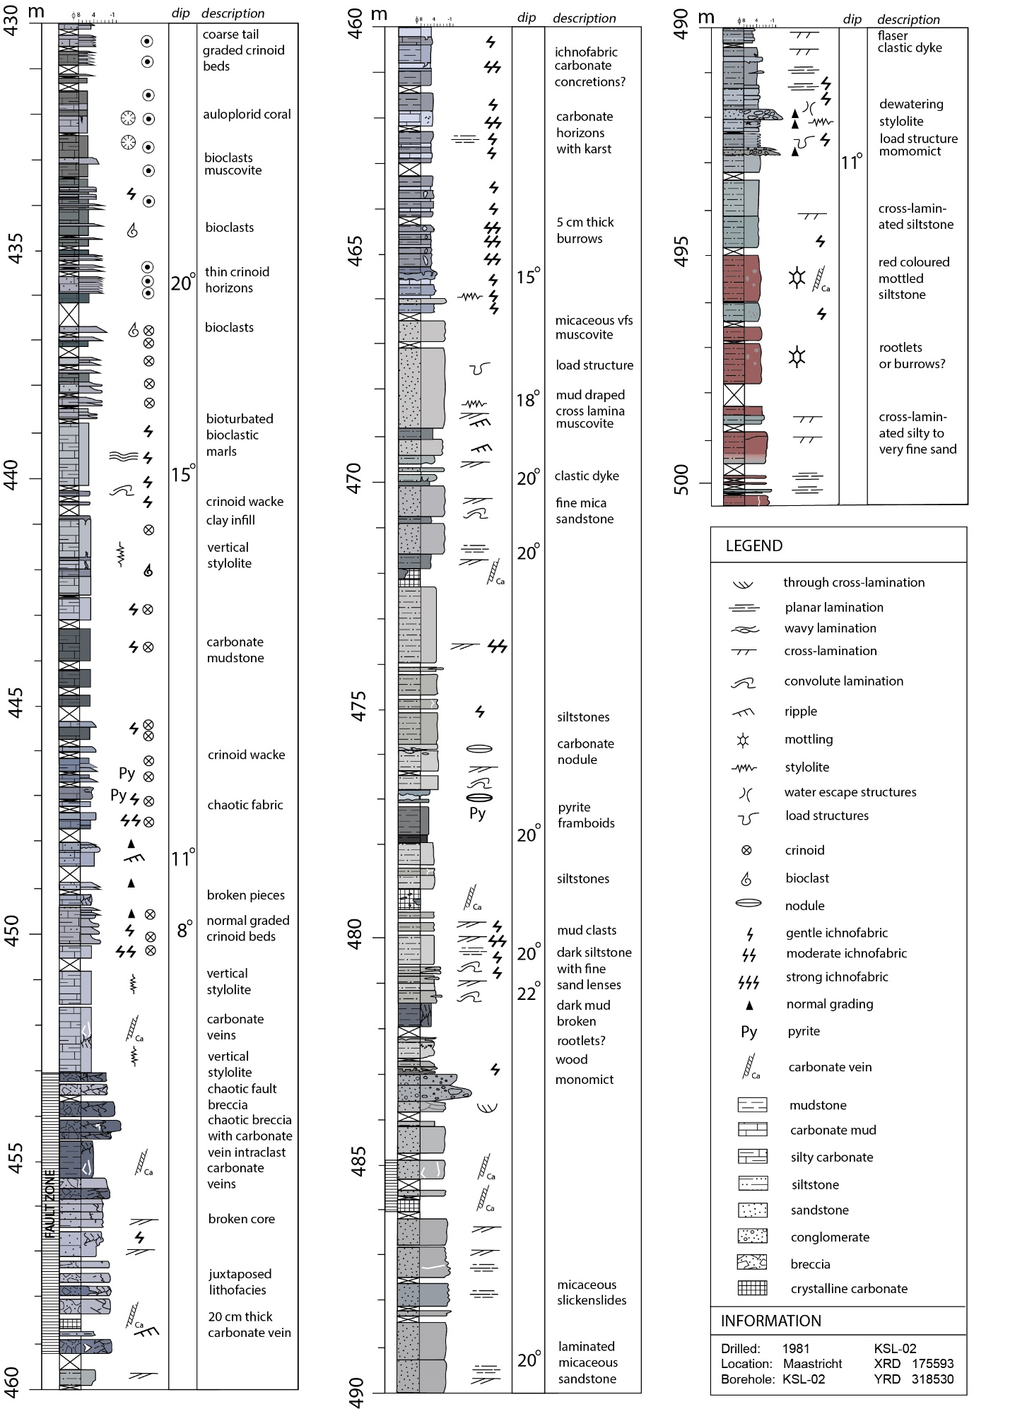
Figure S2.5 Sedimentary log of the KSL-02 core.

Palynostratigraphy

3.1 Approach and Sampling
To obtain age constraints, we conducted palynologic analyses on cuttings, cores, and outcrops (Table S3.1). Rock samples were processed at CGG Laboratories, Conwy, United Kingdom. Samples were first treated with dilute hydrochloric acid to remove calcium carbonate and subsequently macerated by leaving the sample in 75% hydrofluoric acid overnight. The organic residue was sieved over a 53 μm and subsequently a 10 μm mesh. The resultant kerogens of these size classes were visually examined for their degree of brown colouration and the presence of dark macerals, upon which a specific oxidation step was applied. This involves the addition of Schulze reagents, fuming nitric acid and/or warm nitric acid. Both the unoxidised kerogens and the oxidised kerogens were transferred to a glass slide in epoxy resin and covered by a cover slip. The slides with oxidised kerogen were microscopically examined using a transmissive light Leica DM-LB2 microscope fitted with a Leica MC170 digital camera on 787.5× magnification. Each slide was fully scanned and the presence of palynomorph taxa and palynodebris clasts was scored qualitatively. The palynological slides and macerated residues are in the Geological Survey of the Netherlands sample archive.

The palynological study relies on two landmark zonation schemes for the Late Devonian (Streel et al., 1987 and later modifications) and Carboniferous (Clayton et al., 1978). Later, more detailed schemes were made, particularly in light of hydrocarbon exploration in the North Sea (McLean et al., 2005). However, we here refrain from adopting these zones because they are of a level of detail that cannot be achieved with the quality of available material. We do consider the specific events, such as originations and extinctions, that are the foundations of these zonal schemes.

Well/Section | Depth (m) | Type | Productive
KSL-02 | 381 | Core
KSL-02 | 386.6 | Core
KSL-02 | 391.6 | Core | Yes
KSL-02 | 391.8 | Core | Yes
KSL-02 | 395.1 | Core | Yes
KSL-02 | 424.6 | Core | Yes
KSL-02 | 430.3 | Core | Yes
KSL-02 | 447.55 | Core | Yes
KSL-02 | 447.8 | Core | Yes
KSL-02 | 462.85 | Core | Yes
KSL-02 | 465.2 | Core | Yes
KSL-02 | 477.4 | Core | Yes
Cottessen | 28.5 | Core | Yes
Cottessen | 39 | Core
Cottessen | 45.5 | Core
Cottessen | 53.2 | Core | Yes
Cottessen | 63.2 | Core
Cottessen | 64.9 | Core | Yes
Cottessen | 116 | Core
Cottessen | 162.65 | Core | Yes
Cottessen | 182.6 | Core
Cottessen | 213.3 | Core
Cottessen | 235 | Core
Cottessen | 241 | Core | Yes
Terziet-2 | 34 | Cutting | Yes
Terziet-2 | 102 | Cutting | Yes
Terziet-2 | 139 | Cutting | Yes
Terziet-2 | 172 | Cutting | Yes
Terziet-2 | 200 | Cutting
Terziet-2 | 203 | Cutting
RWTH-01 | 20 | Cutting | Yes
RWTH-01 | 40 | Cutting | Yes
RWTH-01 | 50 | Cutting
RWTH-01 | 60 | Cutting
RWTH-01 | 70 | Cutting | Yes
RWTH-01 | 100 | Cutting | Yes
RWTH-01 | 150 | Cutting | Yes
RWTH-01 | 200 | Cutting | Yes
RWTH-01 | 250 | Cutting | Yes
RWTH-01 | 300 | Cutting | Yes
RWTH-01 | 400 | Cutting | Yes
RWTH-01 | 500 | Cutting
RWTH-01 | 580 | Cutting | Yes
RWTH-01 | 660 | Cutting
RWTH-01 | 700 | Cutting
RWTH-01 | 780 | Cutting
Banholt | 147.5 | Core
Banholt | 160.5 | Core
Banholt | 190.5 | Core
Banholt | 228.7 | Core
Dalhem-1 | - | Outcrop | Yes
Dalhem-2 | - | Outcrop | Yes
Table S3.1. Samples analysed or evaluated in this study. Productive means whether processing yielded a sufficient palynomorph concentration for further interpretation.

3.2 Cottessen (ETB-03)
From the cored section of the Cottessen Borehole twelve samples were processed and analysed for palynology. Only five of these yielded discernible palynomorphs (Figure S3.1). For these, the preservation and richness were quite poor, yet the maturity as indicated by the spore colouration index of Fisher (1981) was substantially lower than at KSL-02 (i.e., 7.5 corresponding to a %R₀ of 0.8).

Sample 28.5 m (CO)
Interpreted age: Carboniferous, not further differentiated.
Confidence of age-interpretation: low

This sample only yields long-ranging Carboniferous spores such Densosporites pseudoannulatus and Lycospora pusilla. The samples at 39 and 45.5 m were barren of palynomorphs.

Sample 53.2 m (CO)
Interpreted age: Namurian, Arnsbergian-Kinderscoutian
Confidence of age-interpretation: high

This sample contains several taxa that have a range-base in the early Namurian (Pendleian, NC-Zone of Clayton et al., 1977). These include Savitrisporites nux and Crassispora kosankei. The latter taxon is more abundant and characterized by consistent presence since the middle Namurian (Kinderscoutian). Both taxa range well into the Westphalian. However, reliable younger stratigraphic occurrences such as those of Raistrickia fulva and/or the presence of monosaccate pollen (Florenites, Potoneisporites) are not recorded. Based on the consistent presence of C. kosankei and the absence of taxa with an Arnsbergian or older extinction (e.g., Rotaspora fracta, Cingulizonates cf. capistratus) a late early to middle Namurian (Chokierian to Kinderscoutian) age is most plausible (McLean et al., 2005). Perhaps remarkably, the long-ranging and typically abundant spore Lycospora pusilla which originates in the early Visean is not recorded. This can be due to a specific depositional environment in which a climax vegetation comprising large Lycospora-producing arborescent lycopsids were not developed.

Sample 64.9 m (CO)
Provisional lithostratigraphy: Condroz Fm.
Interpreted age: late Late Famennian
Confidence of age-interpretation: high

This sample constitutes a completely different assemblage compared to the overlying sample. Typical middle to late Late Famennian (e.g., the lower part of the VCo-Zone of Streel et al., 1987 and references therein) taxa are recorded; Grandispora famennensis, Retusotriletes phillipsii and Rugospora flexuosa. A younger (Latest Famennian, or Strunian) age is refuted based on the absence of the marker Retispora lepidophyta.

Samples 162.65 and 241 m (CO)
Provisional lithostratigraphy: Condroz fm.
Interpreted age: early-middle Late Famennian
Confidence of age-interpretation: high

The assemblage from this sample is characterized by elements of the early-middle Late Famennian GF-Zone. The few spinose cavate forms that are recorded at this level more closely resemble Grandispora gracilis. The Rugospora flexuosa – versabilis complex is absent. Instead, trilete spores fit within the genus Retusotriletes (e.g., R. planus, R. incohatus and R. maculatus). A comparable, yet even more poorly preserved assemblage is encountered at 241 m depth.

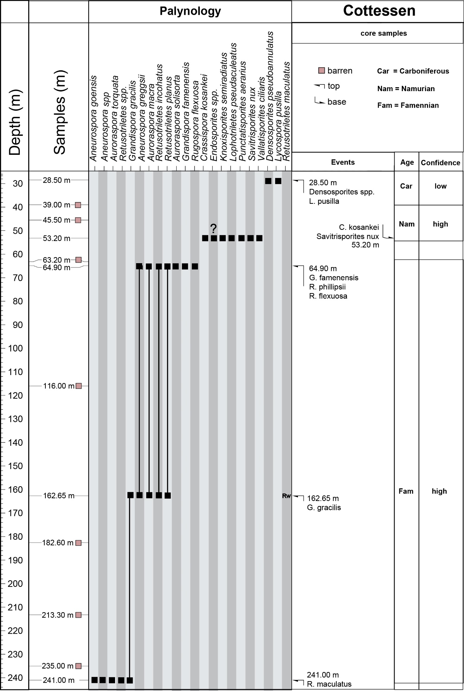
Figure S3.1. Range chart for the Cottessen borehole showing the presence of miospore taxa.

3.3 Terziet-02 (ETB-02)
From the Terziet-2 borehole 7 cuttings samples were palynologically processed and analysed. Of these only the lowermost two (200 and 203 m MD) turned out barren. The samples have a brown-coloration that is comparable to well Cottessen.

Sample 34 m
Interpreted age: mid-Carboniferous, Namurian-A, Chokierian (SO-Zone of Clayton et al., 1978)
Confidence of age-interpretation: high

This interpretation is based on:
- FOD of Bellispores nitidus
- FOD of Crassispora kosankei
- FOD of Kraeuselisporites ornatus
- FOD of Savitrisporites nux

Remark: This sample also contains the Latest Devonian (Strunian) marker Retispora lepidophyta. This implies that Strunian strata were eroded and subsequently reworked during early Namurian times.

Samples 102 and 139 m
Interpreted age: late Late Famennian (VCo-Zone of Streel et al., 1987)
Confidence of age-interpretation: high

At 139 m an assemblage comprising the Rugospora-flexuosa/versabilis complex is encountered. It is also characterized by a more diversified representation of the genus Grandispora, including G. cornuta. This is characteristic for the late Late Famennian VCo-Zone of Streel et al. (1987). Although poorly preserved and lean, a similar assemblage is encountered at 102 m.
Sample 172 m
Interpreted age: early-middle Late Famennian (GF-Zone; Streel et al. 1987)
Confidence of interpretation: high

At 172 m a poorly preserved and scarce assemblage was recovered, only comprising a handful of specimens; including Retusotriletes incohatus, Retusotriles planus and Grandispora microseta. This assemblage is quite comparable to the one recovered at Cottessen at 162.25 and 241 m depth, and which corresponds to the early-middle Late Famennian GF-Zone of Streel et al., 1987.

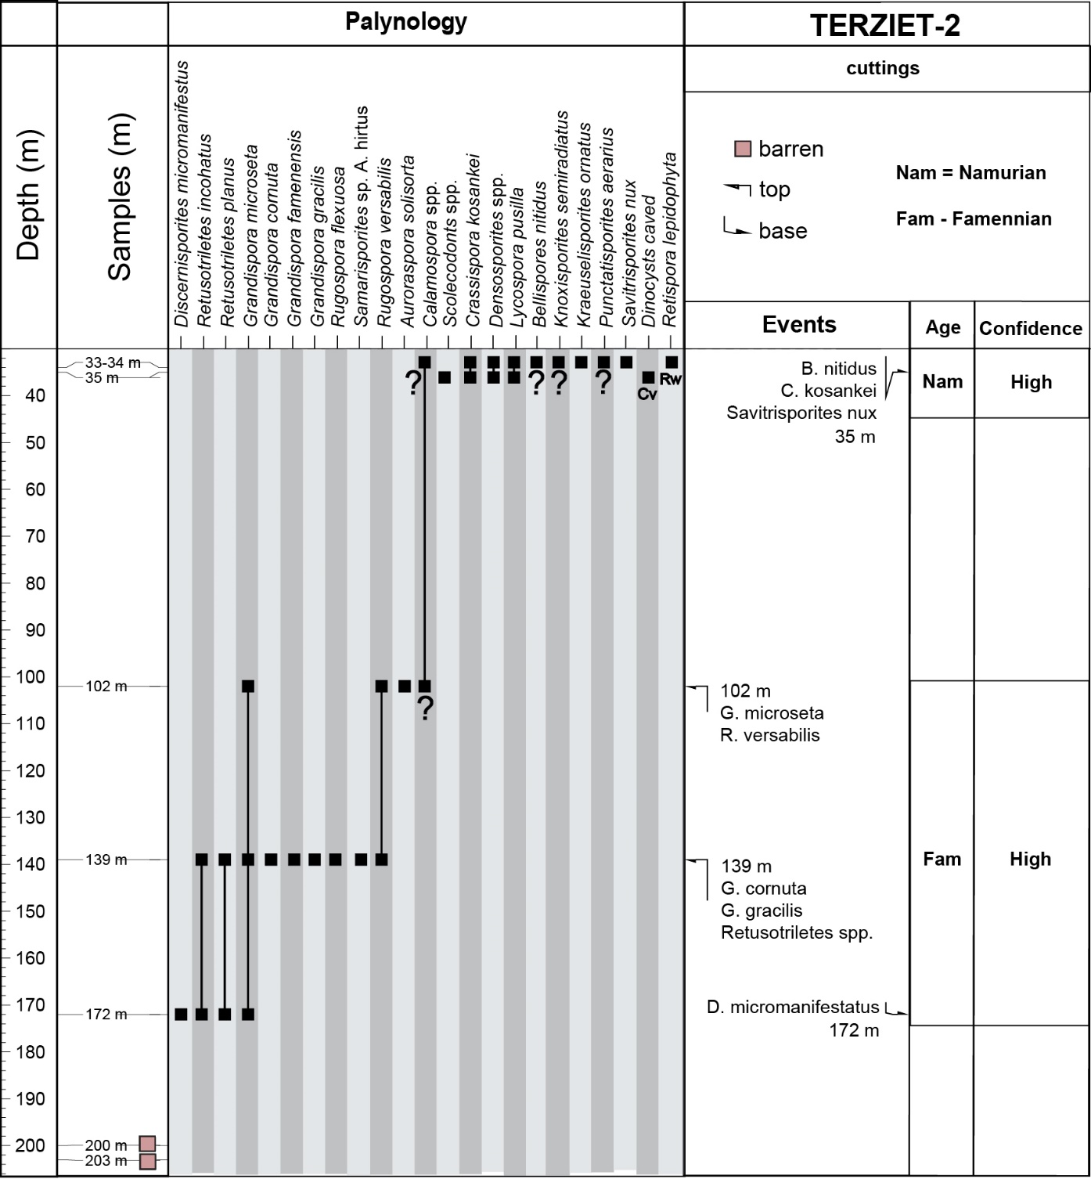
Figure S3.2. Range chart for the Terziet-02 borehole (ETB-02) showing the presence of miospore taxa.

3.4 Banholt – ETB-04

Four samples were processed from the Banholt well. None of them yielded discernible palynomorphs. The three deeper samples (228.7, 190.5 and 160.5 m) constitute a kerogen that looks very dark-colored and degraded, possibly related to intense weathering. The sample at 147.5 m is distinct, it is dominated by far lighter colored wood remains comprising sheets, cuticles and tracheids (Fig. S3.5). However, it does not contain any discernible palynomorphs. This material is likely derived from a coaly source.

3.5 RWTH-01

Based on cuttings and well-log profile, the upper 1025 m are interpreted as Carboniferous, with interpretations diverging as to whether these represent the Westphalian or Namurian. The Dinantian is not present in the well. The Carboniferous strata overly Upper Devonian strata above a thick Lower Devonian succession (Fig. 3.3).
To obtain ages for the Carboniferous succession 12 cutting samples between 50 and 780 m depth were palynologically processed and analysed. Seven of these turned out to be palynologically productive. Although both the preservation and abundance of the encountered miospores were poor the encountered assemblages provide stratigraphic insights. The spore colouration is very dark, comparable to the specimens encountered in well KSL-02.

Interval 20 – 40 m (2 cutting samples)
Interpreted age: late Carboniferous - Pennsylvanian, Westphalian-A (SL-Zone of Clayton et al., 1978)
Confidence of age-interpretation: medium, due to poor preservation and scarce assemblages

This interpretation is based on:
- FOD of Vestispora fenestrata at 20 m
- FOD of Triquitrites sculptulis at 20 m
- FOD of Westphalenisporites irregularis at 20 m
- FOD of Punctatisporites rotundus at 40 m
- FOD of Dictyotriletes bireticulatus at 40 m
- LOD of Bellispores nitidus at 40 m
Remarks: Lycospora pusilla is commonly present indicating a Carboniferous age. The sample at 20 m MD does not contain the long-ranging Namurian-Westphalian spore Crassispora kosankei. This is possibly related to a change in vegetation. The samples at 50 and 60 m are barren of discernable palynomorphs.

Samples 70, 100, 150 and 200 m
Interpreted age: likely Namurian
Confidence of age-interpretation: low

Remark: The preservation of these two productive is very poor. The association comprises Lycospora pusilla, Savitrisporites nux, Bellispores nitidus and Crassispora kosankei, suggesting an early Westphalian or older age. The absence of definite Westphalian markers (e.g., Radiizonates aligerens and/or Dictyotriletes bireticulatus) suggests this interval is Namurian in age.

Samples 300, 400 and 580 m
Interpreted age: mid-Carboniferous, Namurian-A, Chokierian - Alportian (TK-Zone of Clayton et al., 1978)
Confidence of age-interpretation: high, except for position of base

This interpretation is based on:
- LOD of Rotaspora fracta at 300 m
- FOD of Savitrisporites nux at 400 m
- FOD of Bellispores nitidus at 400 m
- LOD of Grandispora spinosa at 400 m
- FOD of Crassispora kosankei at 580 m

Remark: The sample at 500 m is barren of discernible palynomorphs. Possibly the Namurian miospores occurring at 580 m are the consequence of downhole contamination into an otherwise sterile residue. The distinctive and otherwise typically abundant early Namurian taxon Tripartites vetustus is not recorded. It has a reported extinction in the Arnsbergian (early Namurian-A, see Dusar, 2006). Therefore it seems plausible that the interval 580 – 200 m is Chokierian to Alportian in age. The lowermost three samples (780, 700 and 660 m) are barren of palynomorphs.

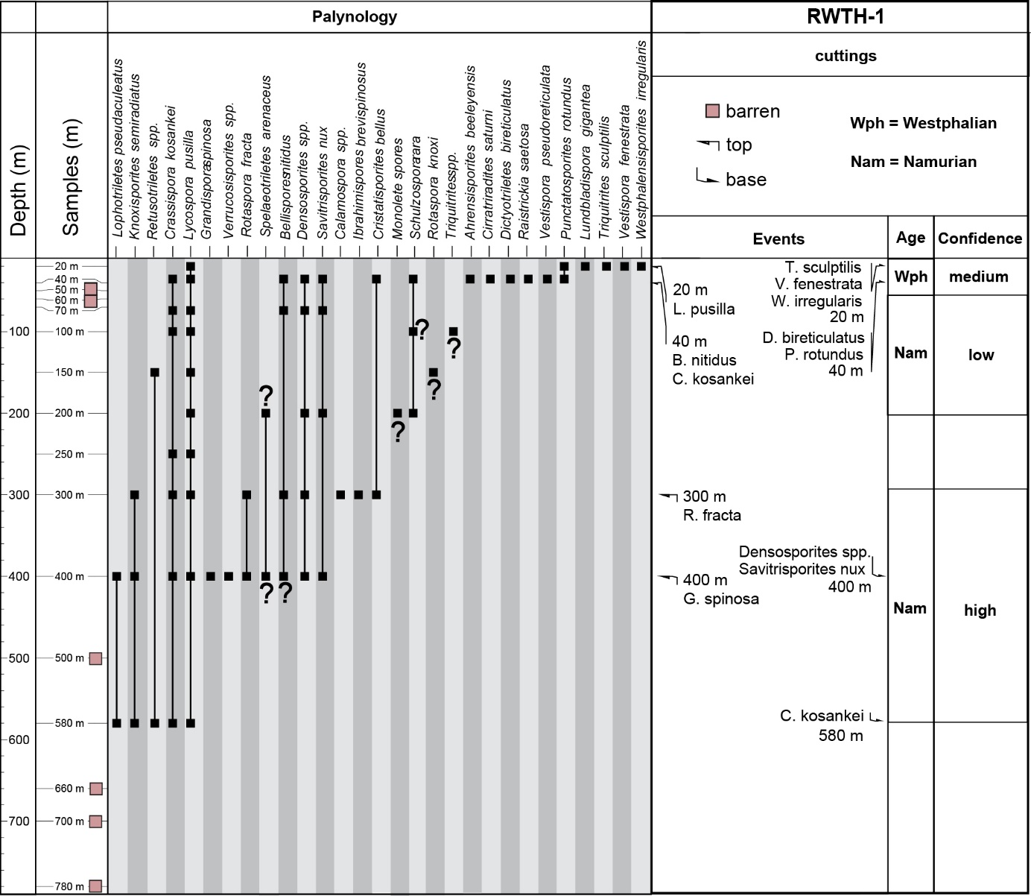
Figure S3.3. Range chart for the RWTH-1 borehole showing the presence of miospore taxa.

3.6 Kastanjelaan-02 (KSL-02)
The cored section from well Kastanjelaan-2 (KSL-02) was studied initially by Bless et al. (1981). These authors recognised three palynological distinct intervals. Their observations are summarised below.

- The interval between 391.6 – 395.1 m (2 samples) corresponds to dark shales of the Pont d’Arcole fm. It yielded the miospores Retusotriletes incohatus, Auroraspora macra, Hymenozonotriletes (now Indotriraditus) explanatus, Corbulispora sp., Aneurospora greggsii, Acanthotriltes spp. and Verrucosisporites spp. The interval also comprises acritarchs; Solisphaeridium astrum, Michrystridium sp., Gorgonisphaeridium sp. and Cymatiosphaera sp.
- The interval between 447.55 m and 462.85 m (3 samples) corresponds to a bioclastic limestone-lithology (here referred to as the Hastiere Fm.) It yields the miospores Spelaeaotriletes (now Retispora) lepidophyta, Spelaeotriletes arenaceus, Hystricosporites multifurcatus, Rugospora flexuosa, Rugospora versabilis and Archaeozonotriletes (now Grandispora) fammenensis.
- At 465.2 m an association with Aneurospora greggsii, Dictyotriletes sp. and Raistrickia variabilis is recovered. This interval also yields abundant occurrences of the acritarch Lophosphaeridium sp. These have been recorded from the Upper Famennian of the Ourthe Valley (Becker et al., 1974).

To validate and further refine the abovementioned observations, five additional samples were analysed in this study. The samples at 381 and 386.6 m are taken from the Pont d’Arcole fm. and do not yield recognizable palynomorphs. The kerogen is dominated by dark angular phytoclasts and tracheids.

The samples at 426.6 and 430.3 m are taken from mudstone intercalations in a bioclastic limestone, provisionally assigned to the Hastiere fm. The kerogen is characterized by a high degree of thermal maturity. The preservation is poor and the palynofacies associations comprise tracheids, phytoclasts and cuticulae. Identified miospores are Spelaeotriletes arenaceus, Raistrickia variabilis, Rugospora versabilis and Retusotrites incohatus. The sample at 477.4 m from mudstone intercalations in the heterolithic basal part of the core, provisionally assigned to the Condroz fm. is overwhelmingly dominated by the miospore taxon Retispora lepidophyta. Other recorded taxa include Grandispora echinata, Retusotriletes incohatus and Raistrickia variabilis.

The following section provides a stratigraphic re-interpretation based on the observations of Bless et al. (1981) and the new analyses, from base to top (Figure 3.4). This is required because the Devono-Carboniferous palynological zonations and their calibration have changed substantially (see e.g., Maziane et al., 1999; Higgs et al., 2013 and Marshall et al., 2018; Denayer et al., 2021) since 1981.
A relevant observation that applies to all samples is the dark coloration of the palynomorphs, all are deeply dark-colored (8.5 on Fisher et al. 1981 coloration scale), which corresponds to an vitrinite-equivalent %R₀-value of 1.5 or a Thermal Alteration Index (TAI) of 3.5 (Suárez-Ruiz et al. 2012).

Samples 462.8, 465.2 and 477.4 m
Interpreted age: early Latest Famennian (early Strunian)
Confidence of age-interpretation: high

This interpretation is based on:
- The FOD of Retispora lepidophyta (large) at basal sample 477.4 m
- The FOD of Grandispora echinata at basal sample 477.4 m
- Absence of Indotradites explanatus in interval

Remark: Bless et al. (1981) note that in the deepest sample they analyzed (465.2 m), Retispora lepidophyta and Rugospora versabilis are absent. This observation was corroborated by our analysis. This subsequently led them to interpret this sample to correspond the middle-late Late Famennian VU-zone of Paproth and Streel (1971). This zone was later renamed as the much more often used VCo-Zone (Paproth et al., 1983; Streel et al., 1987) age. However, the recording of R. lepidophyta and G. echinata at 477.4 m indicates that the basal part of the cored section at KSL-02 is of a latest Famennian (Strunian) age. There is long-standing controverse regarding the palynological zonations of the Strunian and Devonian-Carboniferous boundary interval (viz. the status of the PL-Zone and the LE, LN and LL Subzones, see e.g., Maziane et al., 1999; Higgs et al., 2013 and Denayer et al., 2021). Nevertheless, the absence of Indodtriradites explanatus (the basis for the uppermost Famennian LE Subzone) suggests an early-mid Latest Famennian (Strunian) age for this interval. This is further supported by the relatively large size (>70 µm, see S3.5) of specimens of Retispora lepidophyta in the sample at 477 m. As pointed out Maziane et al. (2002) this taxon underwent an evolution from larger to smaller size towards the D/C-boundary. This supports the assertion that the Condroz fm. strata at KSL-02 are early-middle Strunian in age. It is possible that some geological time is missing at the (fault) contact between the Condroz en Hastiere fm. at KSL-02 (i.e., the LE-Zone, middle Strunian). This cannot be stated with certainty.

Samples 447.55 and 447.8 m
Interpreted age: latest Latest Famennian (latest Strunian)
Confidence of age-interpretation: high

This interpretation is based on:
- the LOD of Retispora lepidophyta (small) at 447.55 m
- the LOD of Grandispora famennensis at 447.55 m

Remark: Bless et al. (1981) assign the three samples between 447.55 and 462.8 to the Strunian PL-Zone of Paproth and Streel (1971). According to Bless et al. (1981) the size distribution of specimens of (between 46 – 61 µm) R. lepidophyta suggests a late Latest Famennian age, close to the extinction of the taxon at the Devonian-Carboniferous boundary (see Maziane et al., 2002). The apparent absence of Verrucosisporites nitidus, which has a widely first occurrence in the latest Famennian (base of the LN-Zone, see Marshall et al., 2018), is a widely recognised phenomenon in Belgium and surroundings. Its absence is ascribed to ecological differences with sections elsewhere (Denayer et al., 2021).

Samples 430.3 and 424.6
Interpreted age: Early Tournaisian, based on superposition
Confidence of age-interpretation: low

Remark: The samples are very poorly preserved and lack definite marker taxa for a Tournaisian age. The LODs of Raistrickia variabilis and Rugospora versabilis at 430 m indicate an age close to the D/C-boundary.

Samples 391.6 391.8 and 395.1 m
Interpreted age: early Tournaisian (older than PC-Zone; Clayton et al. 1977).
Confidence of age-interpretation: high

This interpretation is based on:

- FOD of Aurorospora macra and Indotriradites explanatus at 395.1 m
- The absence of younger Tournaisian occurrences such as Knoxisporites hibernicus, Vallatisporites vallatus and/or Raistrickia clavata (PC-Zone of Clayton et al., 1977)

Remark: The absence of Verrucosisporites nitidus is widespread phenomenon in the study area (Denayer et al., 2021).

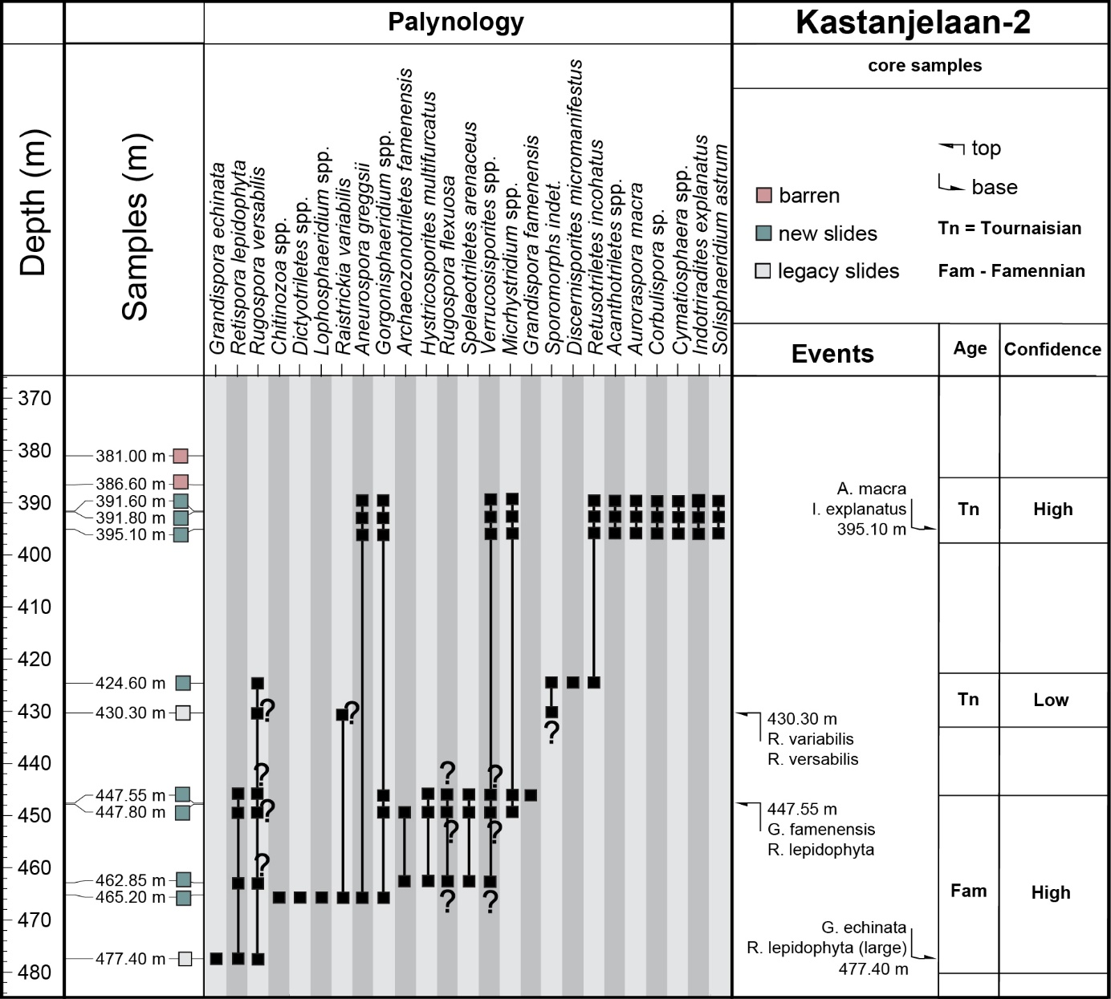
Figure S3.4. Range chart for the KSL-02 borehole showing the presence of miospore taxa.

3.7 Dalhem outcrop

Location: XRD 178805, YRD 302377
Interpreted age: late Carboniferous, Westphalian-A
Confidence of age-interpretation: Low

Two samples were processed from the outcrop section exposed near the train tunnel in Dalhem. They both yield rich but very poorly preserved miospores. The spore coloration is very dark, comparable to the specimens encountered in well KSL-02. The samples are dominated by long-ranging Carboniferous Namurian and younger spores; Lycospora pusilla, Densosporites annulatus and Crassispora kosankei. However the samples also contains very poorly preserved pollen resembling the genera Florenites and Endosporites. In addition, Cirratriradites saturni and Mooreisporites fustis were possibly encountered. This cannot be stated with certainty due to compromised preservation. Yet, this together argues for a younger Westphalian (SS-Zone or RA-Zone of Clayton et al., 1978), although the marker taxa for this zone were not identified.

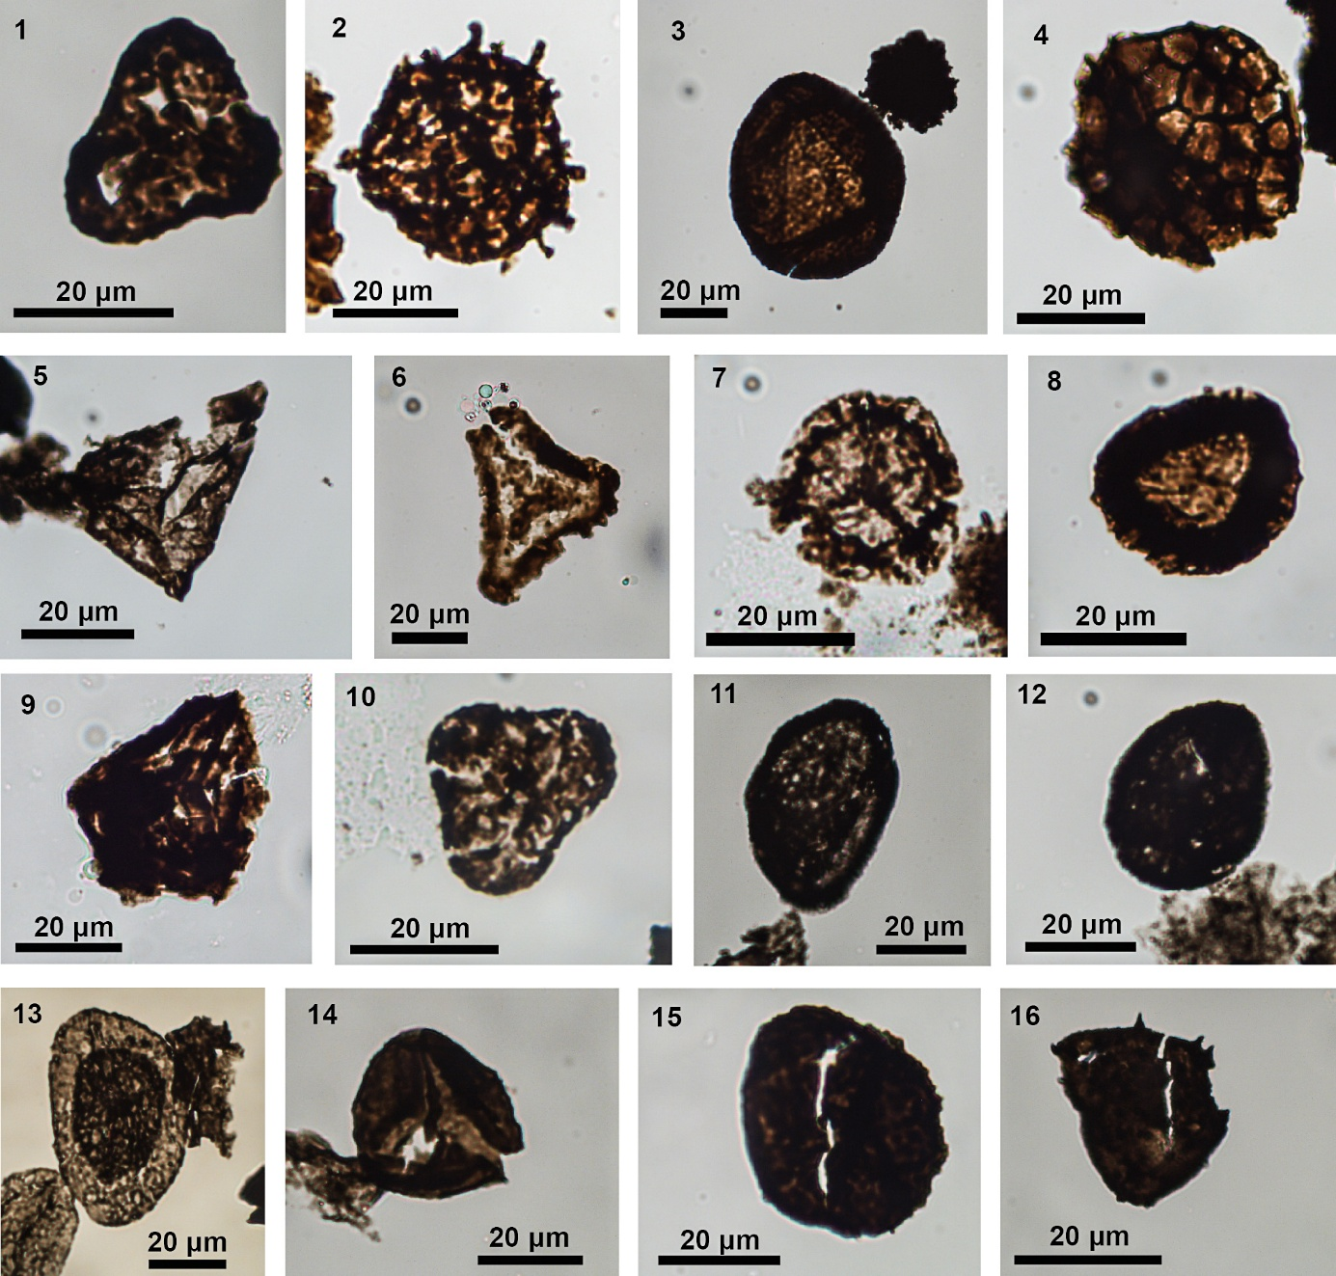
Figure S3.5. Photomicrographs of selected palynomorphs.

- Triquitrites sculptulis RWTH-1 20 m
- Raistrickia spp. RWTH-1 40 m
- Crassispora kosankei RWTH-1 40 m
- Dictyotriletes bireticulatus RWTH-1 40 m
- ?Moreisporites fustis Dalhem oucrop sample
- Rotaspora fracta RWTH-1 400 m
- Lycospora pusilla RWTH-1 400 m
- Densosporites annulatus group RWTH-1 40 m
- Savitrisporites nux RWTH-1 400 m
- Bellispores cf. nitidus RWTH-1 400 m
- Rugospora flexuosa KSL-02 430.5 m
- Rugospora variabile KSL-02 430.5 m
- Retispora lepidophyta KSL-02 177.4 m
- Retusotriletes spp. Terziet-2 139 m
- Grandispora echinata Terziet-2 139 m
- Grandispora cornuta Terziet-2 139 m

Other data and materials

4.1 Stratigrpahic mismatches in geologic map
Comparing borehole stratigraphy as indicated by geodatabase viewers revealed 23 mismatches (Fig. S4.1). Of these mismatches, four are due to false presentation by geodatabase viewers (see main text section 4.3.3). Hence, the geologic map contains 22 stratigraphic errors. The comparison is based on 738 boreholes, of which 50 are unknown or described as Carboniferous - ‘Sokkel Primair’. From the coalfields, 295 boreholes are compared at the stage level Westphalian and therefore reveal no mismatches. As research was historically focused on the coalfields, we expect this region to be well-mapped on an intra-stage level.

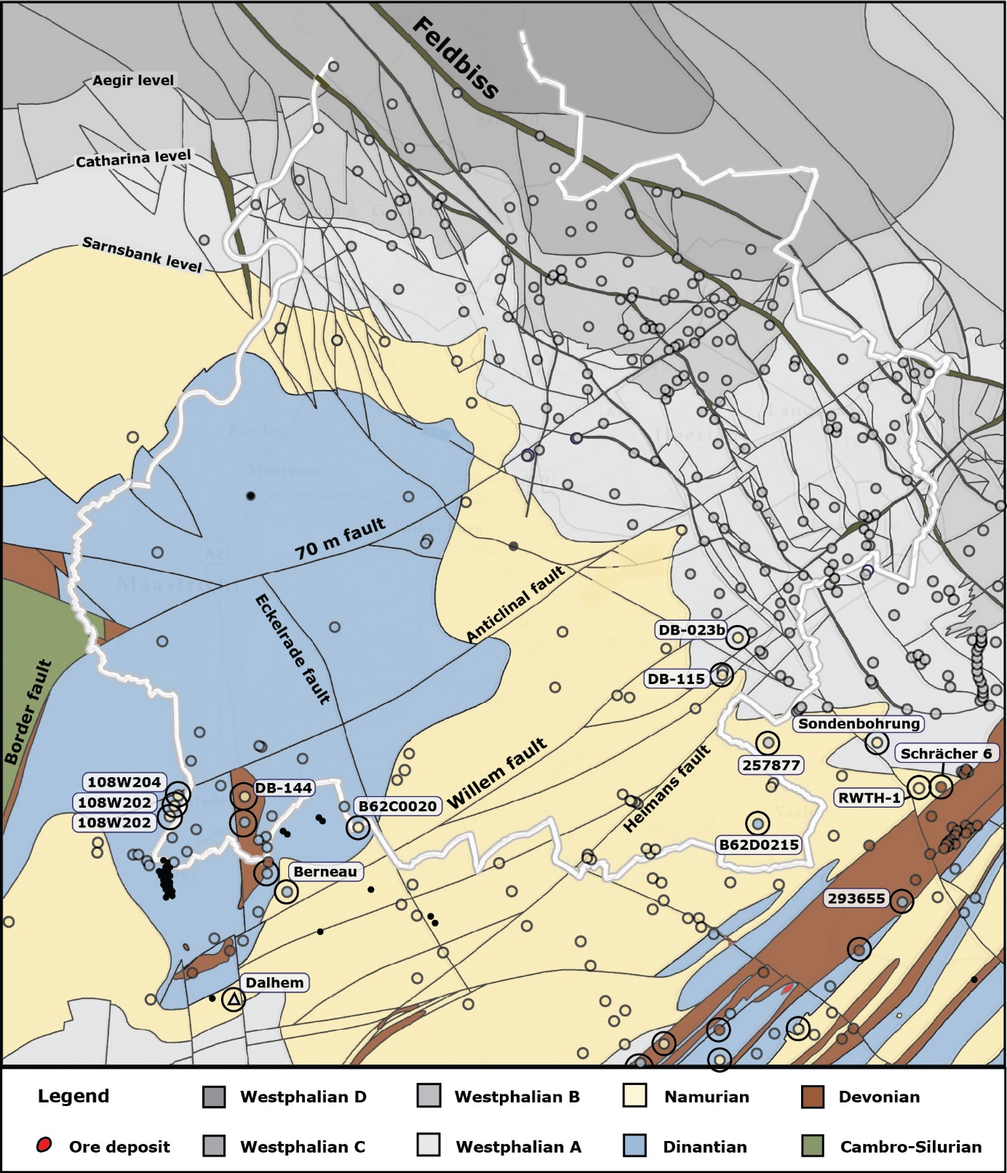
Figure S4.1 Geologic map showing the top-Paleozoic surface, layout adjusted from RGD, (1995). Stratigraphic mismatches between the map and borehole reports or geodatabases are indicated with circles. Note the Dalhem outcrop is indicated as a triangle.

4.2 Val Dieu-Dalhem road section

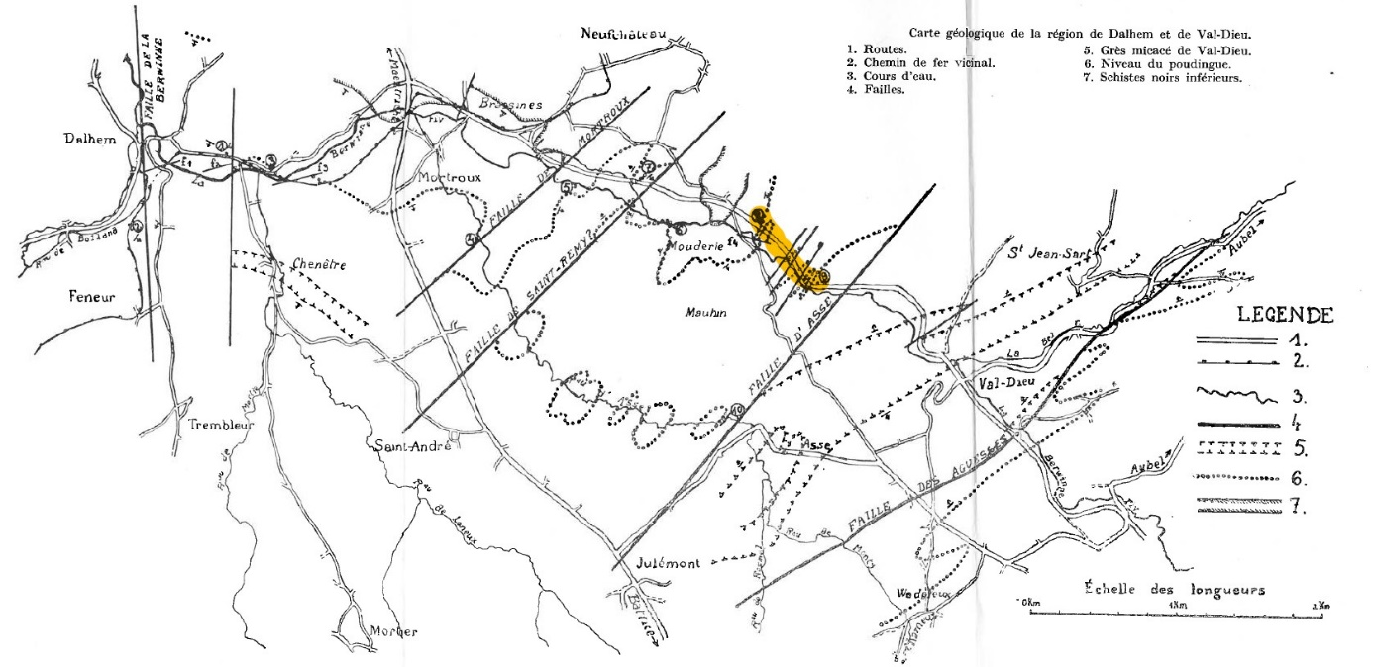
Figure S4.2 Map showing the location of the Val Dieu-Dalhem road section presented in the text as Figure 7 (Raucq, 1942).

4.3 Digital Elevation Model
The Digital Elevation Model shown in Figure 5 of the main text consists of a hill shade and an elevation map downloaded from https://www.mapsforeurope.org/datasets/euro-dem (MAPS for Europe n.d.). The model describes the terrain, excluding vegetation and buildings. The elevation model was converted to the coordinate system - Amersfoort RD new – using ArcGIS Pro® (Esri, 2016). The greyscale was adjusted to gain more contrast by adjusting levels in Adobe Photoshop (Adobe Inc. 2024).

Terminology

Type | Term | Explanation
a | ambiguity | the recognition that data can be interpreted in two or more ways probable ways.
a | ambiguous lithofacies | lithofacies that are non-exclusive to a particular stratigraphic unit
a | reworked microfossils | when older microfossils are eroded from their original sedimentary deposit and then get redeposited into younger sediments
a | uphole contamination in cuttings | when material falls into the borehole and mixes with the cutting sample during acquisition, resulting in the artificial introduction of microfossils from overlying strata.
a | indiscernible data | data that reveals little to no information, so that no interpretation can be drawn
b | uncertain scaling heuristics | the uncertainty of using fault zone thickness as indicator for fault offset and other fault dimensions
b | variable fault dimensions | natural variation of fault zone thickness within a single fault or compared to other faults
b | fracture-bedding similarity in BHI | the resemblance of similarly oriented bedding planes and fractures in borehole image logs
b | uncertainty in fault recognition | uncertainty arising from interpreting ambiguous breccia textures
b | uncertainty in interpreting fault zone thickness | uncertainty arising from problems in pinpointing the outer limit of a fault damage zone
c | semantic misunderstanding | a mismatch that occurs when processed data is understood differently as intended by the data provider
c | unincorporated updates | stratigraphic amendments for specific boreholes that remain unincorporated in geodatabase viewers, creating a mismatch between the latest knowledge and the data presented
c | data reworking | adjustments made to processed data or input materials in a collective dynamic
d | change in biostratigraphic framework | biostratigraphic calibration of microfossil assemblages is changed in respect of the chronostratigraphic chart, creating inconsistencies with older literature.
d | change in concepts | interpretations are made under an assumption or paradigm that has evolved after scientific knowledge has accumulated, and new insights have progressed
d | invalid assumption | interpretations were made under reasonable assumptions that were later revealed to be invalid by new data
d | cognitive bias | an umbrella term for different unconscious biases affecting interpretation and decision-making
Table S5.1. Terms indicated in Figure 17 of the main text and theirexplanations. Typers refer to table 1 of the main text.

