Supplementary Information
SI.1 precipitation deficit over time
Figure SI.1 shows the precipitation deficit (precipitation – evapotranspiration defined as the EV24 in open source KNMI data (KNMI, 2025), where the deficit is calculated between April 1st and September 30th), measured at four locations close to the locations of interest presented in this work. The precipitation deficit has been decreasing from 2022 to 2024. 2018 and 2020 have been relative dry years.
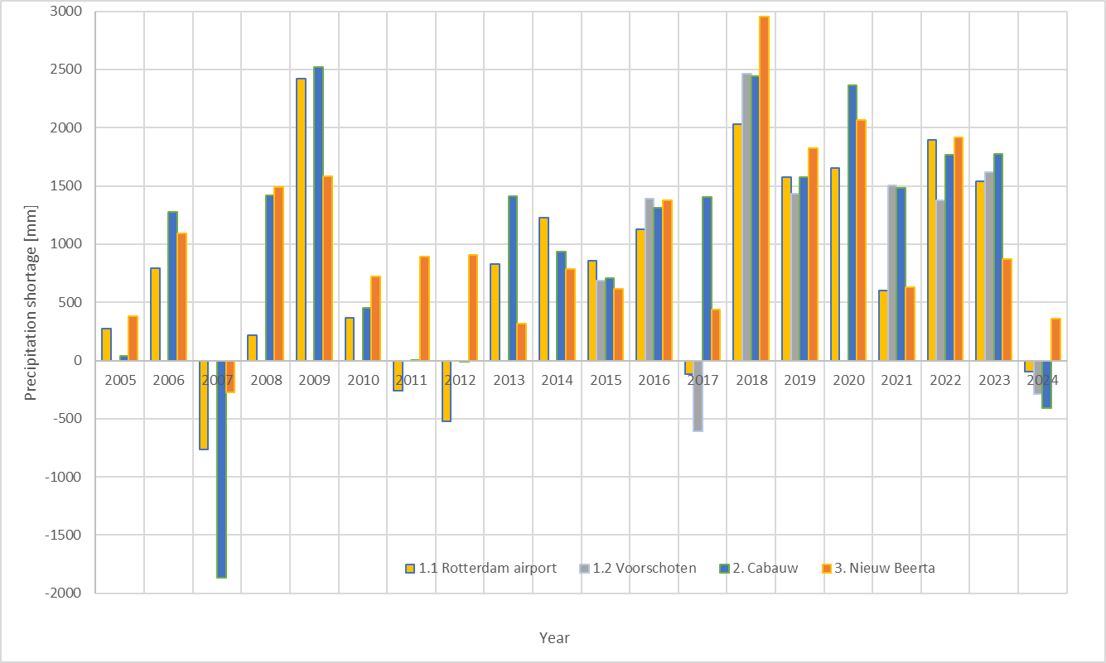
Figure SI.1 the precipitation deficits at KNMI measurement locations near the sites.
SI.2 Particle size distribution
Before analysing the particle size distribution, organic matter and carbonate minerals were removed from the samples using 30% H₂O₂ and 10% HCl, respectively. Organic matter was removed first by adding H₂O₂ until no visible reaction occurred, even after shaking the sample. The H₂O₂ solution was then removed through repeated cycles of centrifugal sedimentation and replacement with deionized water in the sample tubes. The same procedure was subsequently carried out with HCl to remove carbonate cementing agents.
The prepared sample was then loaded into the particle sizer together with 25 mL of a peptising solution containing Na₄P₂O₇·10H₂O. Prior to measurement, the sample was subjected to 60 seconds of ultrasonic treatment and analysed immediately afterward. Measurements were performed on a Malvern Mastersizer 2000 in wet dispersion, using a particle refractive index of 1.544 (quartz) and an absorption index of 0.9. The instrument settings and the per-sample measurement quality parameters (obscuration and weighted residual) are summarised in Tables SI.1 & SI.2. The results are shown in Fig. SI.2. Samples from Sites 2 and 3 contain a higher proportion of fines (<20 µm) than those from Site 1.
The grain size distributions of samples with a relatively high sand content, should be interpreted with some caution. The reason for this is that laser diffraction assumes spherical particles and results may be affected by the settling of coarse grains and by the masking of finer particles by larger ones, which introduces uncertainty in the measured distribution, particularly at the coarse end. For this reason, the distributions are used in this study only as supporting, contextual information and are not used in the quantitative analyses underlying our conclusions on soil shrinkage and land surface movement.

Table SI.1. Malvern Mastersizer 2000 measurement settings (identical for all samples).
Parameter | Value
Instrument | Malvern Mastersizer 2000
Dispersion | Wet
Particle refractive index | 1.544 (quartz)
Particle absorption index | 0.9
Dispersant | Sodium pyrophosphate peptising solution (25 mL)
Ultrasound pre-treatment | 60 s immediately before measurement

Table SI.2. Per-sample measurement quality parameters and key percentiles of the grain size distributions. d10, d50 and d90 are the particle diameters below which 10, 50 and 90 % of the sample volume lies; D[4,3] is the volume-weighted mean diameter.
Sample | Obscuration (%) | Residual (%) | d10 (µm) | d50 (µm) | d90 (µm) | D[4,3] (µm)
S1.1 | 19.36 | 0.36 | 5.6 | 55.2 | 115.4 | 59.5
S1.2 | 20.10 | 0.35 | 3.5 | 47.5 | 110.0 | 52.2
S1.3 | 20.50 | 0.35 | 4.0 | 51.9 | 112.8 | 55.9
S2.1 | 17.28 | 0.77 | 1.2 | 6.1 | 33.3 | 12.4
S3.1 | 21.24 | 0.90 | 1.0 | 4.5 | 22.5 | 19.9

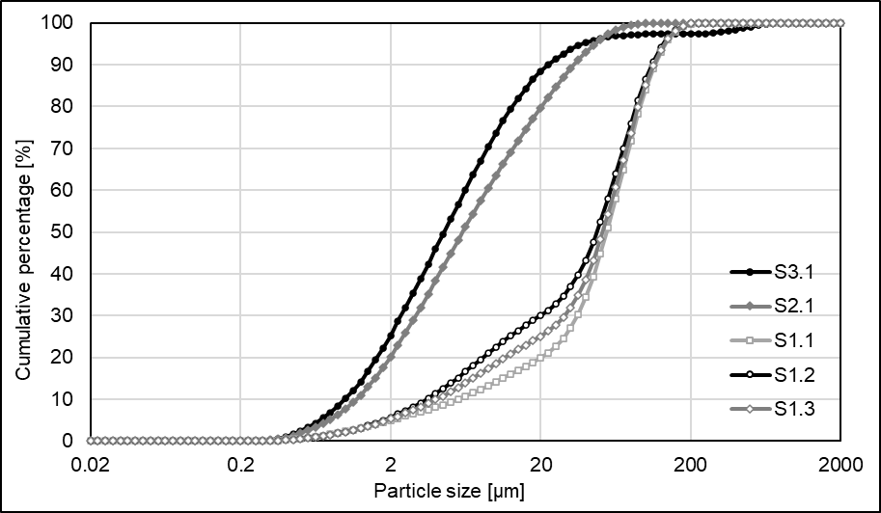
Figure SI.2 The grain size distributions of the samples studied in this study. S1 refers to Site 1, Hazerswoude; S2 to Site 2, Cabauw and S3 to Site 3 Nieuwolda.

SI.3 HYDRUS 1D simulation
For all three locations simplified HYDRUS Water Flow simulations were performed to understand the VWC profile in relation to the textural shifts in the shallow subsurface. The simulations were based on the texture of the upper 60 cm of the soil profiles (Van Asselen et al., 2020). For Site 1, Hazerswoude, this resulted in two layers defined as silty clay (0-22 cm depth, originally defined as “sterk siltige klei”) and loam (22-60 cm depth, originally defined as “zwak zandig leem”). For Site 2 and 3, Cabauw and Nieuwolda, the upper 60 cm was described as silty clay.
For Site 2 and 3, the texture of the shallow subsurface was homogeneous, resulting in VWC profiles that coincide with the suction profiles. For these two locations the subsurface was divided in a minimal number of simulation layers as defined in the methods of the main manuscript.
For Site 1, the combination of the relatively fine grained surfacing layer of silty clay, overlying loam creates a VWC profile that consists of two parts. An example of a simulated VWC profile (no precipitation, only a small amount of evaporation and the average (during period of interest) phreatic groundwater level of 78 cm below the surface) is shown in Fig SI.3. The simulation layer intervals defined in the methods of the main manuscript are based on this simulation, to incorporate the shift in VWC between the silty clay and loam textural classes.
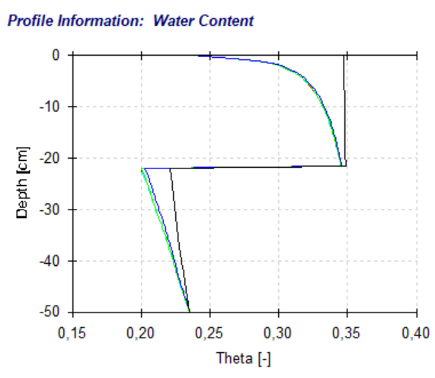
Figure SI.3. Result of a simulation of the volumetric water content with depth for a simplified set of input parameters for Site 1, Hazerswoude.
SI.4 Lab-based matric-suction shrinkage relations
Table SI.3 summarizes the relations between matric suction and the deformation of the samples that have been applied in the work presented.
Table SI.3. Relations matric suction and relative sample dimensions, noted down with two decimal places (full formulas noted down in SI), in which S is the matric suction [kPa] and the outcome is the relative dimension (H=vertical, V=volumetric).
Sample/  Relation | Relation relative dimensions and soil matric suction
Site 1
S1.1 H | -1.50E-8*S^3 + 3.31E-06*S^2 – 2.59572137370905E-4*S + 1
S1.2 H | If S<80 kPa then  2.29E-10*S^6 - 2.53E-08*S^5 + 1.10E-06*S^4 - 0.0000238*S^3 + 0.000277*S^2 - 0.00199*S + 0.997 otherwise  3.18E-09*S^4 + 6.87E-07*S^3 - 0.0000520*S^2 + 0.00156*S + 0.970
S1.3 H | If S<21 kPa then  3.00E-10*S^6 - 3.28E-08*S^5 + 1.40E-06*S^4 -2.95E-5*S^3 + 3.30E-4*BV10^2 - 2.18E-3*S + 1  otherwise  -4.24E-11*S^5 + 1.12E-08*S^4 - 1.15E-06*S^3 + 5.73E-5*S^2 - 1.43E-3*S + 1.00
S1.1 V | 2.42E-11*S^5 - 5.62E-09*S^4 + 4.05E-07*S^3 - 4.02E-06*S^2 - 0.00068*S + 0.99
S1.2 V | 2.97E-12*S^6 - 8.59E-10*S^5 + 9.54E-08*S^4 - 5.15E-6*S^3 + 1.40E-4*S^2 - 2.00E-3*S + 0.995
S1.3 V | If S<30 kPa then  2.29E-10*S^6 - 2.53E-08*S^5 + 1.10E-06*S^4 -2.38E-5*S^3 + 2.77E-4*S^2 -1.99E-3*S + 1  otherwise  -3.18E-09*S^4 + 6.87E-07*S^3 - 5.20E-6*S^2 + 1.56E-3*S + 0.97
Site 2
S2.1 H | If S<2.2 kPa then  6.74E-4*S^6 - 7.20E-3*S^5 + 2.94E-2*S^4 - 5.73E-2*S^3 + 5.59E-2*S^2 - 2.99E-2*S+ 0.999  otherwise  7.05E-14*S^6 - 3.39E-11*S^5 + 6.38E-09*S^4 - 6.00E-07*S^3 + 3.05E-5*S^2 - 9.69E-4*S + 0.989
S2.1 V | If S<3.4 kPa then  5.71E-4*S^6 - 6.59E-3*S^5 + 2.91E-2*S^4 – 6.06E-2*S^3 + 5.94E-2*S^2 – 3.08E-2*S + 0.999  otherwise  2.42E-13*S^6 - 1.12E-10*S^5 + 2.05E-08*S^4 - 1.93E-06*S^3 + 0.000100*S^2 - 0.00322*S + 0.9851

SI.5 Interpolation suction for Site 2: Cabauw
Due to data gaps, the suction measured at 20 and 50 cm depths was interpolated for Site 2: Cabauw. Figure SI.4 shows the results of the interpolation compared to the measured matric suction at a depth of 35 cm.
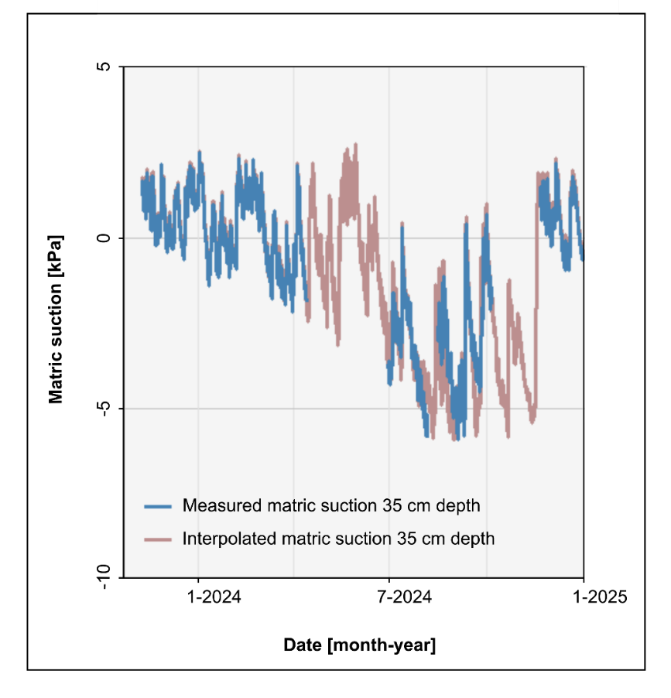
Figure SI.4 The agreement between measured and interpolated matric suction at a depth of 35 cm at Site 2: Cabauw.

SI.6 Shallow subsurface layer deformation in relation to temperature for Site 3: Nieuwolda
The comparison between the temperature measured at a depth of 20 to 35 cm depth is shown in Fig. SI.5.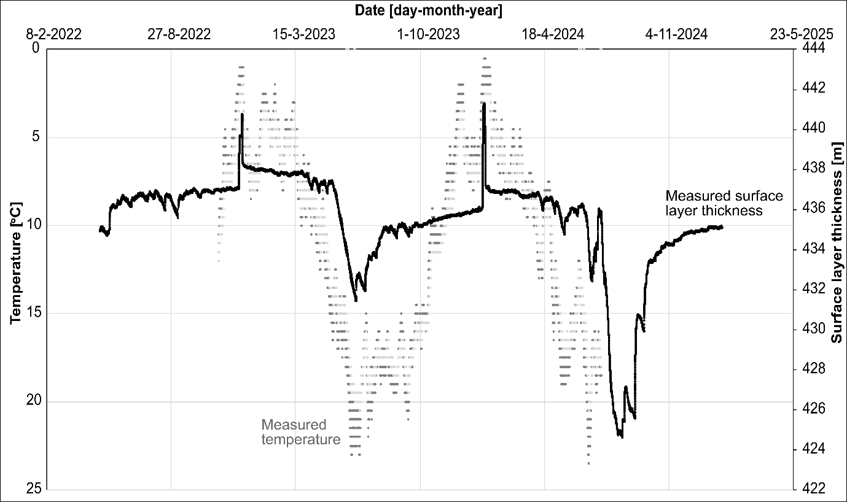Figure SI.5 The temperature (left vertical axis, values reversed; grey dots) and the surface layer (7-50 cm depth) thickness change (right vertical axis; black line) over time of Site 3: Nieuwolda. Two peaks in thickness during cold (1 degree or colder) days.
SI.7 Groundwater level in relation to shallow subsurface layer deformation
The groundwater level increases up to very close to the land surface at Site 1: Hazerswoude. The comparison to slow swell in the shallow subsurface layer is shown in Fig. SI.6.
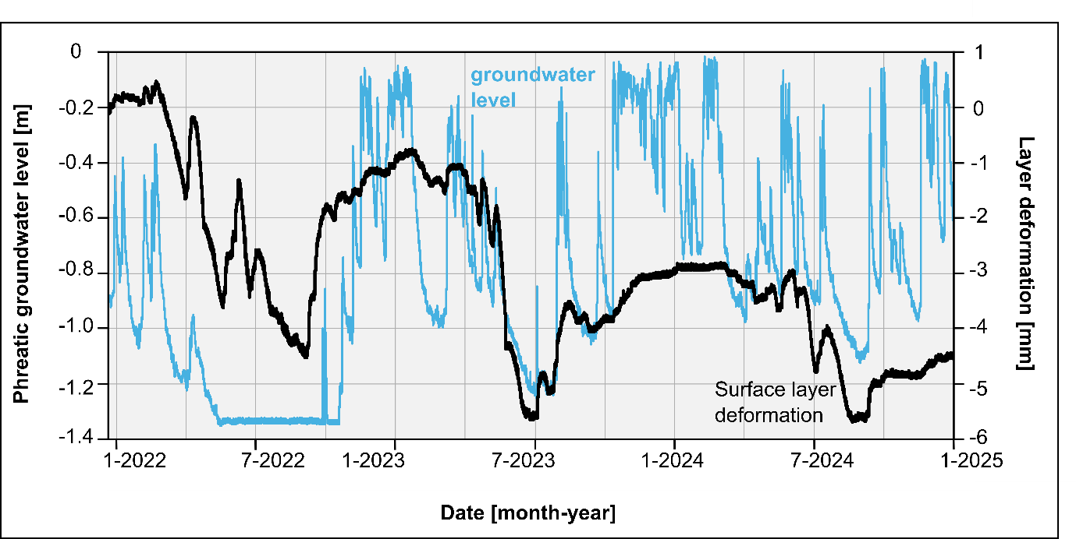Figure SI.6. The groundwater level measured at Site 1: Hazerswoude, in combination with the measured layer deformation of the initial 7-50 cm depth layer.
References SI.
KNMI. (2025). Daggegevens van het weer in Nederland. Visited November 16th 2025, https://www.knmi.nl/nederland-nu/klimatologie/daggegevens
van Asselen, S., Erkens, G., & de Graaf, F. (2020). Monitoring shallow subsidence in cultivated peatlands. Proceedings of the International Association of Hydrological Sciences, 382, 189-194.

