Supplementary Material

Supporting Information for

Confirming b-value spatial variations in Groningen gas field using machine-learning–derived seismic data
Laura Gulia^{1,2}* and Stefan Wiemer¹

¹Swiss Seismological Service, ETH, Zurich, ² University of Pisa, Italy

*corresponding author: laura.gulia@unipi.it

Kamer and Himer (2015) proposed to adopt a non-arbitrary partitioning scheme based on a Voronoi tessellation as an alternative approach to map b-value. The method described in Kamer and Himer (where the grid is defined through a random analysis) is implemented at regional scales and used by the authors to perform a spatial analysis of the b-value for California. In the small region of the Groningen field, with a limited number of available data, a higher level of resolution is needed. Moreover, when observations are few, closely spaced and confined within a relatively small region, the resulting Voronoi polygons may even exceed the location uncertainty associated with the local seismic network.
We have however implemented a Voronoi modified approach, to show that results shown in Figure 3 are not influenced by the grid and the radius adopted. Our implementation differs substantially from the approach proposed by Kamer and Hiemer (2015) because, as explained above, their approach is designed to identify the statistically optimal partitioning of a seismic domain at the regional scale. Although the Bayesian Information Criterion (BIC) optimisation is rigorous and effective when applied to large-scale regional catalogues (e.g. California), it is less suitable for the analysis of a confined reservoir system such as the Groningen field. In such a restricted spatial domain with a relatively limited dataset, the BIC penalisation criterion tends to oversimplify both the geometry and the number of Voronoi cells, effectively smoothing out the local b-value gradients that constitute the primary focus of this study.
To overcome this limitation, we adopted the seismic hypocentres themselves as the seeds of the Voronoi tessellation. This methodological choice provides an inherently adaptive spatial resolution, whereby the level of detail naturally follows the distribution of seismicity and is concentrated in areas with higher event densities, without being constrained by subjective criteria usually associated with the definition of a regular grid.
Furthermore, to ensure the statistical robustness required for b-value estimation using the b-positive method, the tessellation was coupled with a fixed search radii from 3 to 7 km around the centroid of each Voronoi cell. This threshold is essential to ensure that the b-value assigned to each cell is derived from a sufficient number of observations (at least 50 positive magnitude differences; Figures A1-A5).
At 3 and 4 km (Figures A1-A2), information is lost (at 3 km few cells have an associated b-value); however, when the radius is increased to 6 or 7 km (Figures A4-A5), the gradients of b-value are entirely consistent with the trend shown in the maps in Figure 3. The maps confirm that a 5 km radius (Figure A3) offers the best balance between resolution and information. These maps show that even when the radius is varied and a different grid/approach is used, the trend in the field is exactly the same as shown in Figure 3.

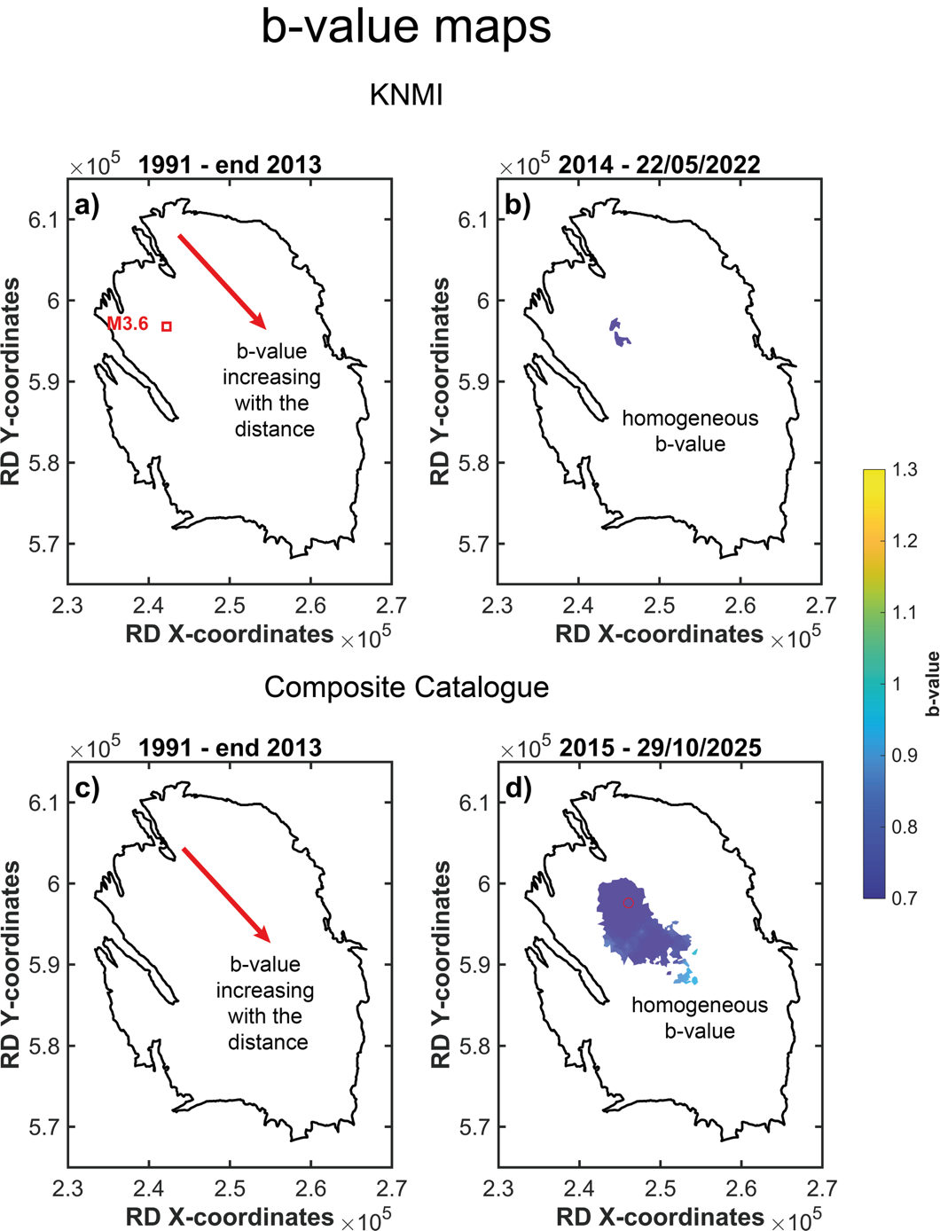

Figure A1 - Comparison of spatial b-value maps from (a–b) Gulia (2023) and (c–d) this study, for the same two production periods (see main text). Maps are computed with the b-positive estimator (minimum 50 positive magnitude differences) using the modified Voronoi approach described in this Appendix, for a radius of 3 km.

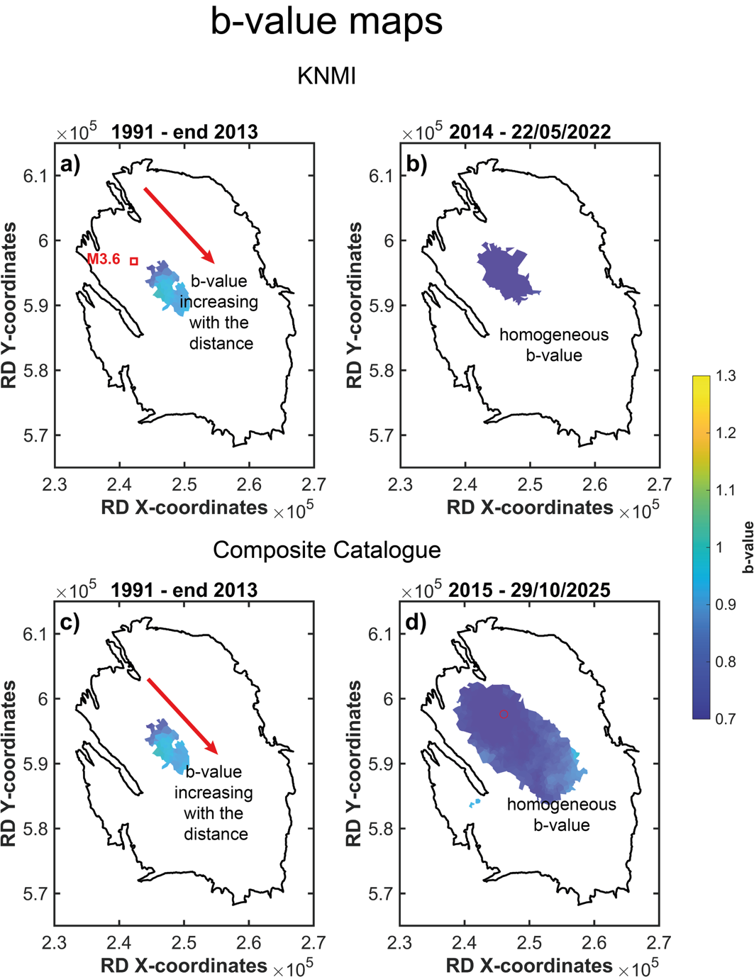
Figure A2 - Comparison of spatial b-value maps from (a–b) Gulia (2023) and (c–d) this study, for the same two production periods (see main text). Maps are computed with the b-positive estimator (minimum 50 positive magnitude differences) using the modified Voronoi approach described in this Appendix, for a radius of 4 km.

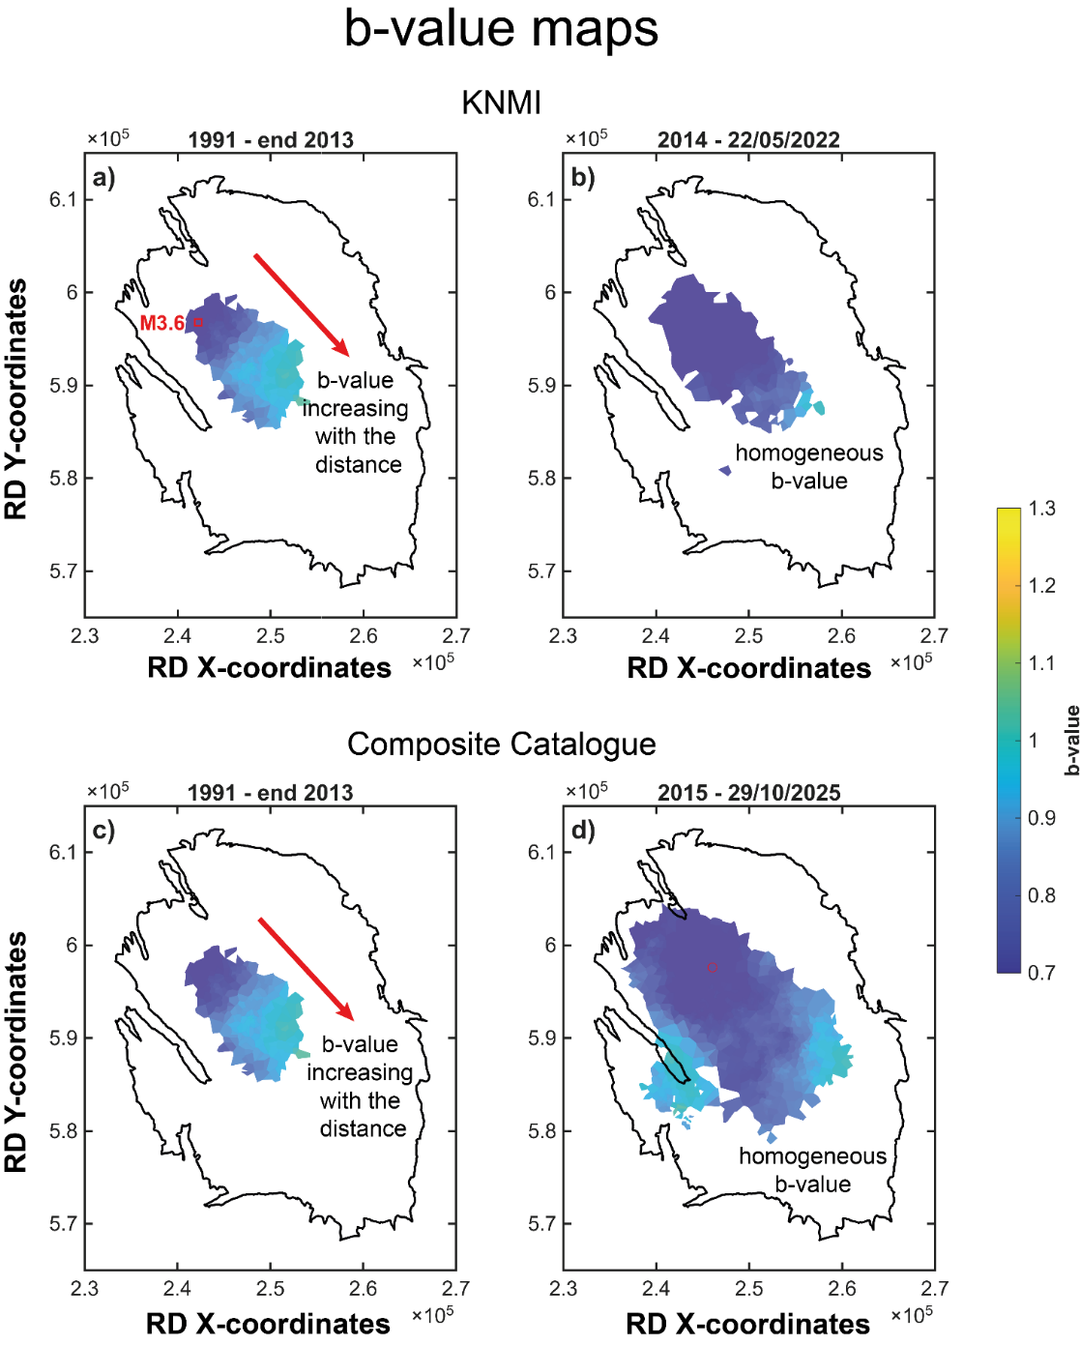

Figure A3 - Comparison of spatial b-value maps from (a–b) Gulia (2023) and (c–d) this study, for the same two production periods (see main text). Maps are computed with the b-positive estimator (minimum 50 positive magnitude differences) using the modified Voronoi approach described in this Appendix, for a radius of 5 km.

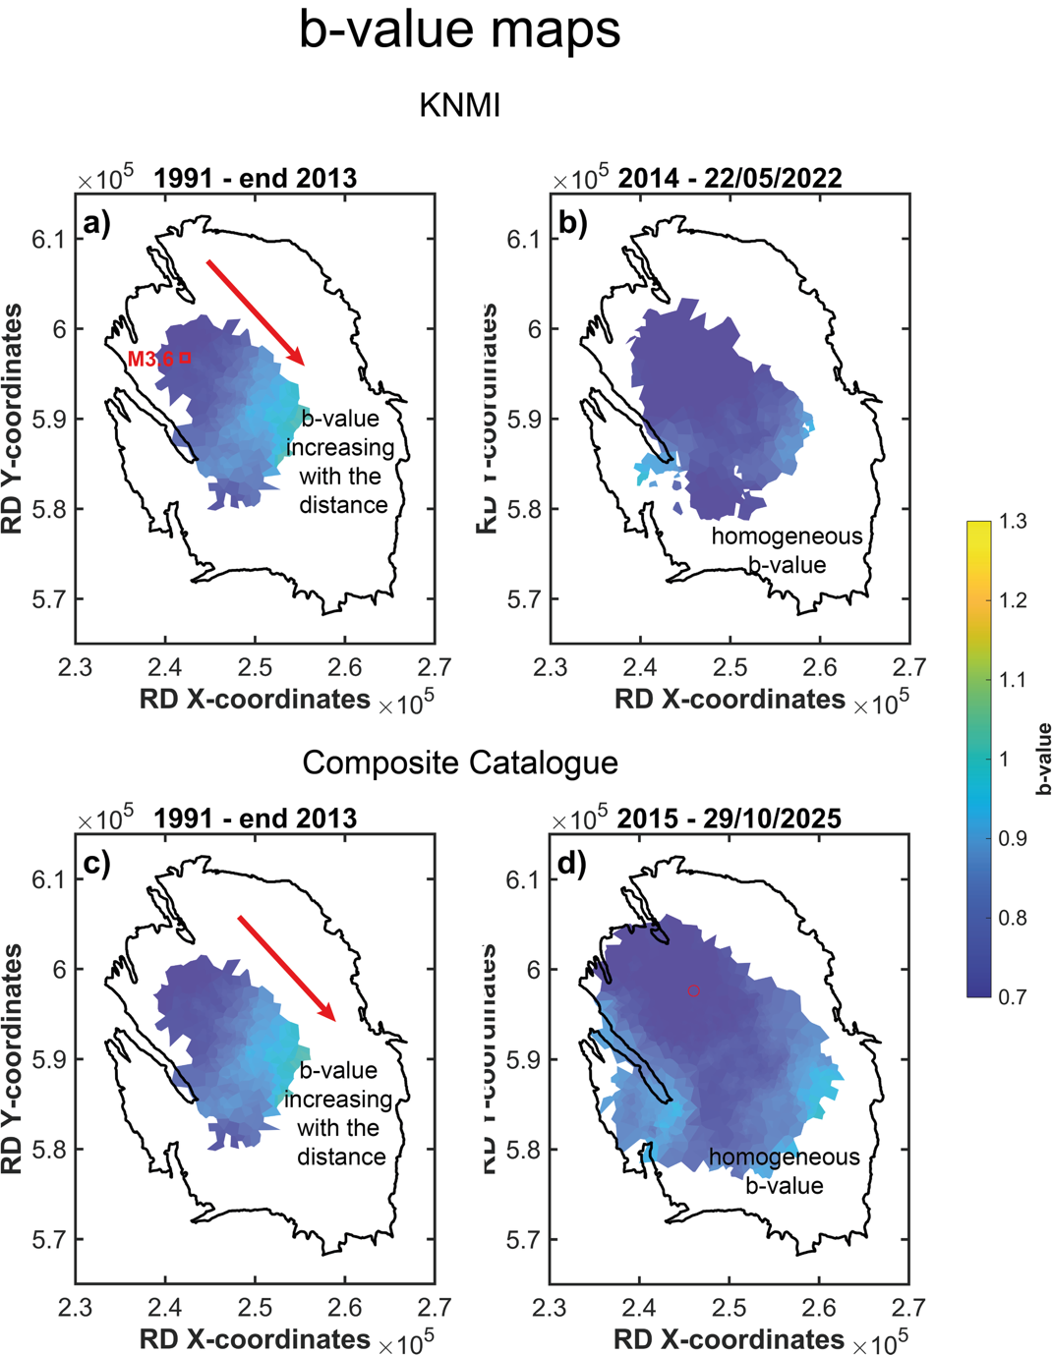

Figure A4 - Comparison of spatial b-value maps from (a–b) Gulia (2023) and (c–d) this study, for the same two production periods (see main text). Maps are computed with the b-positive estimator (minimum 50 positive magnitude differences) using the modified Voronoi approach described in this Appendix, for a radius of 6 km.

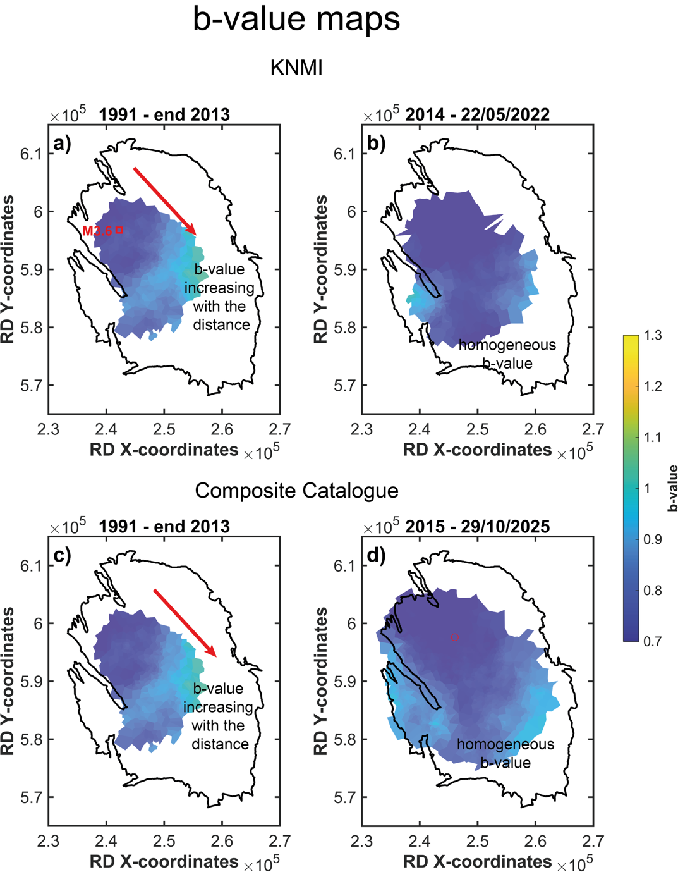
Figure A5 - Comparison of spatial b-value maps from (a–b) Gulia (2023) and (c–d) this study, for the same two production periods (see main text). Maps are computed with the b-positive estimator (minimum 50 positive magnitude differences) using the modified Voronoi approach described in tise Appendix, for a radius of 7 km.

References
Gulia, L., 2023. Time–space evolution of the Groningen gas field in terms of b-value: insights and implications for seismic hazard. Seismological Research Letters 94 (4): 1807–1820
Kamer, Y., & Hiemer S., 2015, Data-driven spatial b value estimation with applications to California seismicity: To b or not to b, Journal of Geophysical Research: Solid Earth, 120, 5191–5214, doi:10.1002/2014JB011510.

